Unit 4: The Financial Sector

Exam Date:
Multiple Choice: To Be Announced
(Probably between March 18 to 23rd)
No Graphing Test

Advanced Placement Macroeconomics Exam
Unit 4 - Financial Institutions

Test Date (Within a day or two)
Multiple Choice: To be announced No graphing test

(NOT TO BE OUTLINED) Total Textbook Pages covered
1. Chapter 12 - page 229 to 232 "what 'backs' the money supply" and page 234 "The Federal Reserve and the Banking System" to page 238 "The Federal Reserve and Independence" (It's all covered in a guided reading you will receive)
2. Chapter 13 - all

Graphs
No new graphs this unit.

Unit 3 Key Concepts
measures of the money supply, fractional reserve banking, the Federal Reserve System, banks, multiple deposit
expansion, money creation, fractional banking, T accounts, money multiplier, required reserves, reserve ratio, excess reserves, total reserves,

Crucial Activities - Resources
1. Guided Reading - Money and the Federal Reserve
2. Macroeconomics Lesson 1 Activity 35 What's All This About the Ms?
3. Macroeconomics Lesson 1 Activity 34 Money
4. Note Packet Fractional Banking and Money Creation
5. Macroeconomics Lesson 1 Activity 35 What's All This About the Ms?
Lesson 1, Activity 37 The Multiple Expansion of Checkable Deposits"
6. Unit 4 Practice Test

Name ____________________________________________________ Hour ____________
Guided Reading - Money and the Federal Reserve (Start on page 228)
1. List and explain the 3 functions of money:
a.

b.

c.

2. Money is said to be a preferred store of value because it is the most liquid of all assets. Explain what this means (one quick word is not enough for credit).

3. What are the components of the narrowest definition of the U.S. money supply, M1?
a.

b.

4. U.S. coins are examples of token money. What does this mean?

5. Fill in the blanks, "Most of the nation's currency is paper money. This "folding currency" consists of

_______________________________________ issued by the _______________________________________

(the U.S. central bank) with the authorization of ___________________________________.

6. What percent of the M1 money supply is:
A. Currency? B. Checkable deposits?

7. To summarize: Money, M1 =

8. List institutions that allow customers to create checkable deposits, and put a star by the primary one (the collective name of the second kind is fine for credit).

9. Even though money that you have deposited in a bank in the form of a checking account is an asset to the bank (cash), it is not counted as money for them. Why not?

10. M2 money = M1 plus Near-monies. What are Near-Monies?

11. What 3 categories of near-money does the text list?
a.

b.

c.

12. How much larger is the M2 money supply than the M1 money supply alone?

13. MZM (Money Zero Maturity) focuses exclusively on monetary balances that are …

14. The Equation for MZM =

Go to page 234 - The Federal Reserve and the Banking System
15. Various sections of the text have referred to "monetary authorities." These are authorities that can actually influence, if not outright control, the nations overall supply of money. In the U.S., who are these "monetary authorities?"

16. As figure 12.2 shows, the board directs the activities of ________________________________________,

which in turn control the lending activity of the nation's ___________________________________________.

17. What law created the Federal Reserve System?

18. Explain the nomination process and the terms of the members of the Fed's Board of Governors (Be complete, and don’t forget the chair-person and vice-chairperson).

19. Unlike most nations which have one single central bank, the Board of Governors directs the activity of how many Federal Reserve banks throughout the nation?

20. Rather than being motivated by profit like private banks are, what are the goals of the policies that these Federal Reserve banks carry out?
21. Look at figure 12.3. What Federal Reserve district is Michigan in, and where is the Federal Reserve Bank located that serves our state's banks?

22. Why do you think that some Federal Reserve districts include several states while others include just a few?

23. How is the relationship between the Federal Reserve banks and the local banks in their districts analogous to (like) the relationship between our local banks and us?

24. Continuing this point from the last question, in emergency circumstances, the Federal Reserve Banks

become the "__________________________________________ " to the banking system.

25. What special function do Federal Reserve Banks have which other banks and thrifts certainly do not have?

26. As we shall learn, Monetary Policy includes policies of the Fed to influence the total supply of money available in the nation. What committee of the Fed assists the Board of Governors in this all-important task?

27. Who are the 12 individuals who make up Committee?
a.

b.

c.

28. List the 7 main functions of the Fed. Explain the one with an * a bit since it is not as self-explanatory as the others.
a.

b.

c.

d.

*e.

f.

g.

29. Unlike Congress and the President, who are beholden to the electorate (dependent upon voters for their jobs), Congress intentionally created the Fed as an independent agency. Why?

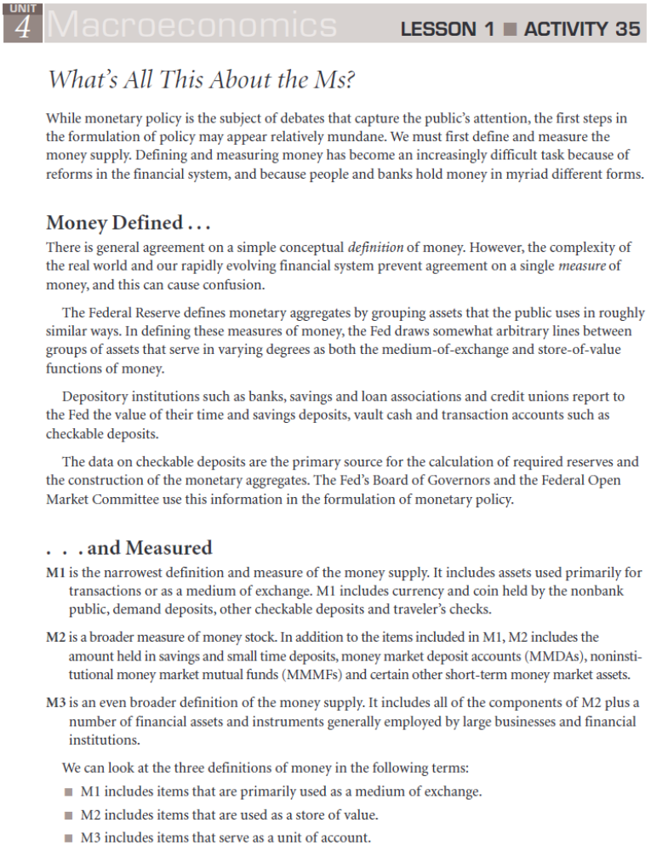
Name ________________________________________________ Hour __________
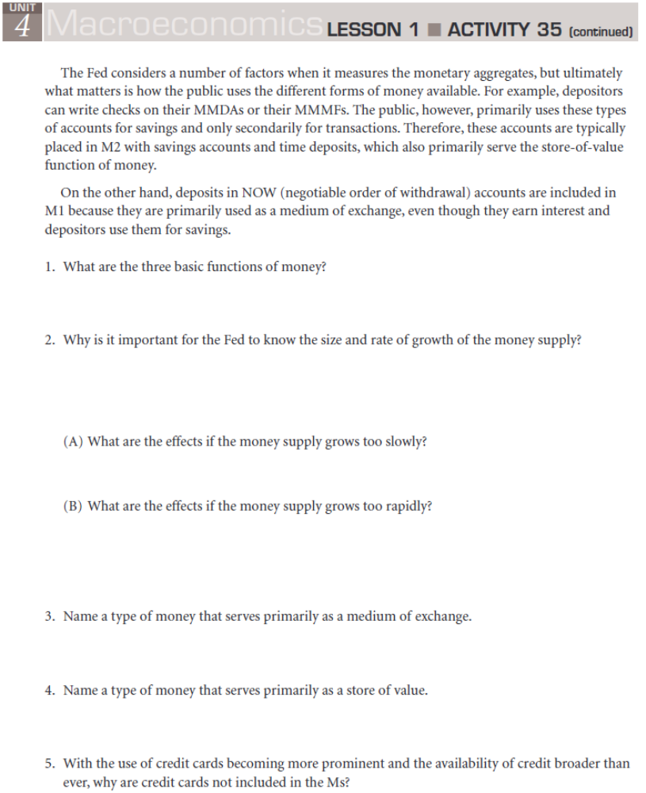

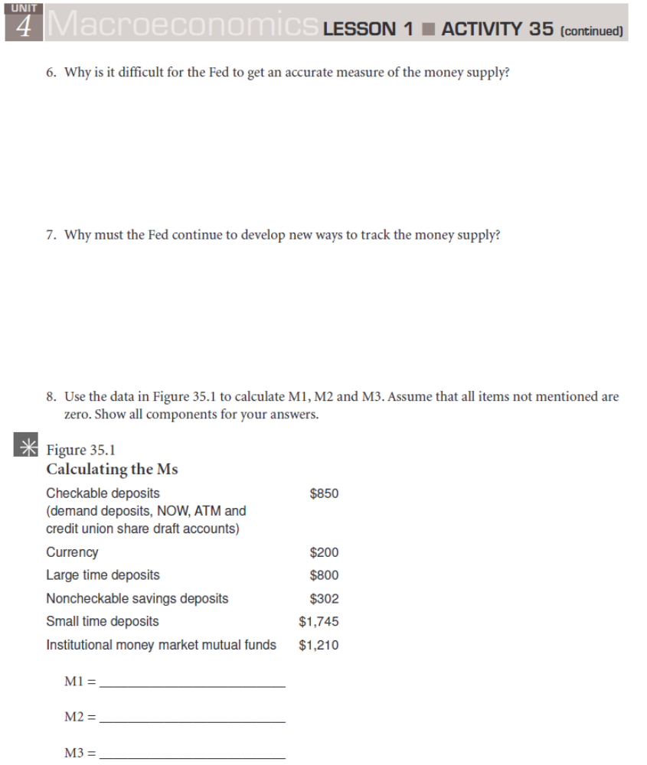

Name ______________________________________________________ Hour __________
Notes - Fractional Banking and Money Creation (Chapter 13 - all)
I. Fractional Banking: Only a portion (fraction) of checkable bank deposits (deposits that checks can be written on) are actually backed up by cash in:
A. | B.

II. A bank's Balance Sheet (Also called its ___________________ ) - A statement of a bank's:
A. Assets - | B. Claims against the bank by:  1. - called liabilities  2. - called networth.

C. Assets =

D. Every $1 change in a bank's assets is matched by …

__________________________________________________________________________________________
III. Bank Transactions

1. Bank founders sell __________________ worth of stock to the public (and to themselves) with which to create Wahoo Bank.
Transaction 1:
Balance Sheet 1: Wahoo Bank
Assets Liabilities and Networth
Cash: | Stock Shares:

2. The Bank buys __________________ worth of property and Equipment
Transaction 2:
Balance Sheet 2: Wahoo Bank
Assets Liabilities and Networth
Cash:  Property: | Stock Shares:

3. Fred Bradshaw and other Citizens deposit ________________ in the bank as checkable deposits (checking accounts).
Transaction 3:
Balance Sheet 3: Wahoo Bank
Assets Liabilities and Networth
Cash:  Property: | Checkable Deposits:  Stock Shares:

IV. Required Reserves:

- Reserve Ratio:

B. Reserve Ratio =

C. _________________ can establish and vary the reserve ratio within limits set by_______________.

D. _____________________ help the Fed control the ______________________ of commercial banks.

4. Wahoo Bank deposits all of its cash with the Federal Reserve
Transaction 4:
Balance Sheet 4: Wahoo Bank
Assets Liabilities and Networth
Cash:  Reserves:  Property: $240,000 | Checkable Deposits:  Stock Shares: $250,000

IV. The Reserve Ratio Continued.

E. Excess Reserves:

F. Excess Reserves =

G. Required Reserves:

H. Required Reserves =

I. For Wahoo Bank, if the Fed sets the reserve ratio at 20%, what are Wahoo banks current
1.) Required Reserves? 2.). Excess Reserves?

J. Therefore, legally Wahoo bank
- Must keep and not loan out… 2.) May loan out…

5. Fred Bradshaw writes a check for __________________ and the Fed processes the transaction.
Transaction 5:
Balance Sheet 5: Wahoo Bank
Assets Liabilities and Networth
Reserves:  Property: $240,000 | Checkable Deposits:  Stock Shares: $250,000
Questions: At this point, what are Wahoo banks…
a. Required Reserves? b. Excess Reserves?
6a. Wahoo bank loans out an amount equal to its extra reserves to a borrower by granting him a ___________ checking account in return for a promissory note (an IOU).
Transaction 6a:
Balance Sheet 6a: Wahoo Bank
Assets Liabilities and Networth
Reserves:  Loans:  Property: $240,000 | Checkable Deposits:  Stock Shares: $250,000

1. Note - By loaning an amount equal to its extra reserves, Wahoo bank has actually created …

2. The borrower gave the bank something that cannot be spent, a _________________________, a fancy

_____________, a promise to pay money back in the future.

3. The bank gave him something that can be spent, …

6b. The borrower writes a check for the entire amount of the loan which is processed by the Fed.
Transaction 6b:
Balance Sheet 6b: Wahoo Bank
Assets Liabilities and Networth
Reserves:  Loans:  Property: $240,000 | Checkable Deposits:  Stock Shares: $250,000
__________________________________________________________________________________________
V. Abiding by the Reserve Ratio

A. Note - A Single Bank Can Only Lend…

B. Loaning out more than ones excess reserves will leave the bank with less than its required reserves once the loaned money is spent.

3. Example: Alternative 6a. Look back to Transaction 6a. Wahoo bank has excess reserves of $50,000. Let's assume it loans out $55,000 instead of the $50,000 it actually did.
Alternative Transaction 6a:
Balance Sheet 6a: Wahoo Bank
Assets Liabilities and Networth
Reserves:  Loans:  Property: $240,000 | Checkable Deposits:  Stock Shares: $250,000

6b. The borrower writes a check for the entire amount of the loan which is processed by the Fed.
Alternative Transaction 6b: After a check is drawn on the loan
Balance Sheet 6b: Wahoo Bank
Assets Liabilities and Networth
Reserves:  Loans:  Property: $240,000 | Checkable Deposits:  Stock Shares: $250,000

a. Required Reserves? b. Actual Reserves?

c. Wahoo bank would be in violation of the Fed's Reserve Requirement

VI. Government Securities
A. The government borrows money from US Citizens by selling "___________________" to the public (Like US savings bonds) and then buying them back with interest later.

B. Banks sometimes buy these securities from the public as investments.

C. Bonds, like promissory notes, are not money. …

D. So when a bank buys a government security like a bond from a member of the public in exchange for money, it is just like issuing a loan, accepting a promissory note in exchange for money. Both ...
__________________________________________________________________________________________

7. Going from Transaction 5 to 7 instead of to 6a: The bank buys __________________ in bonds.
Transaction 7:
Balance Sheet 7: Wahoo Bank
Assets Liabilities and Networth
Reserves:  Securities:  Property: $240,000 | Checkable Deposits:  Stock Shares: $250,000
Notice how Balance Sheet 7, buying government securities, and Balance Sheet 6a, When a Loan is Negotiated, are virtually identical. In both cases, ….

VII. Money Creation.
A. In our fractional banking system, by extending loans …

B. When loans are repaid…

C. By buying government securities …

D. By selling government securities…

F. Note, Banks can only make loans or buy securities in an amount equal to…

G. The amount of money that can be created is limited by …
VI. Multiple Deposit Expansion

A. The amount of money created by banks in the lending process actually greater than the amount that is initially loaned out.

B. Let us make 3 assumptions (for purposes of demonstration)
1. The Reserve Requirement is …

2. All banks are "loaned up," that is, they all loan out …

3. All money borrowed from a bank eventually ends up ….

4. Figure 13.2
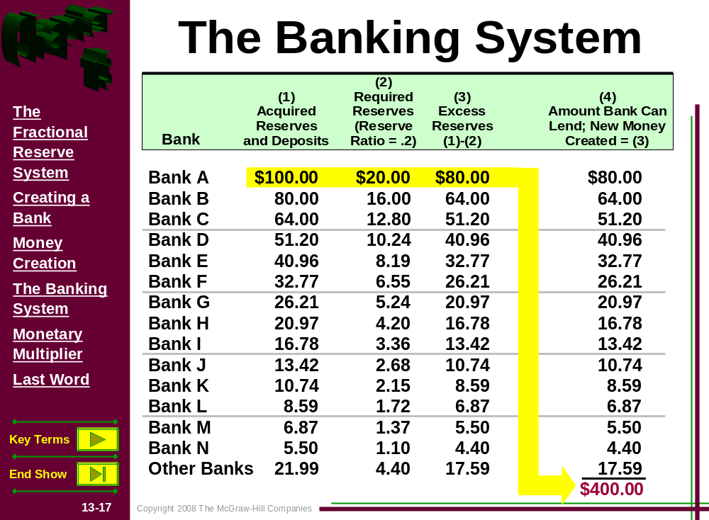

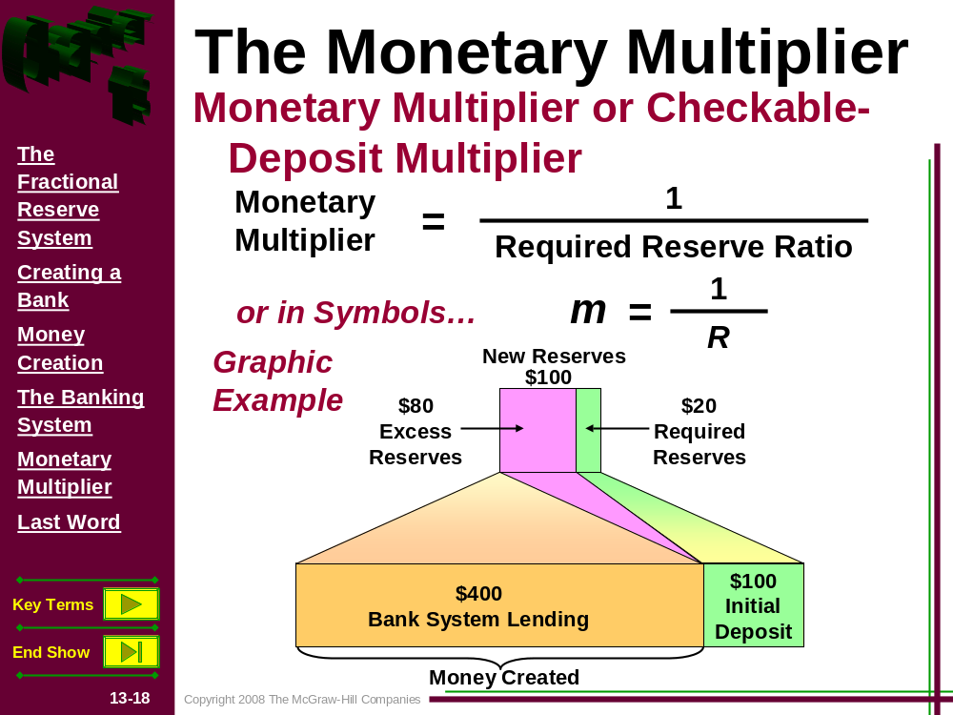

C. Total Expansion of the money supply =

D. The Monetary Multiplier =

VII. The Multiple Destruction of Money

A. Making loans …

- Loan repayment …

- For the overall money supply to increase,

the dollar amount of loans made must be the dollar amount of loans repaid

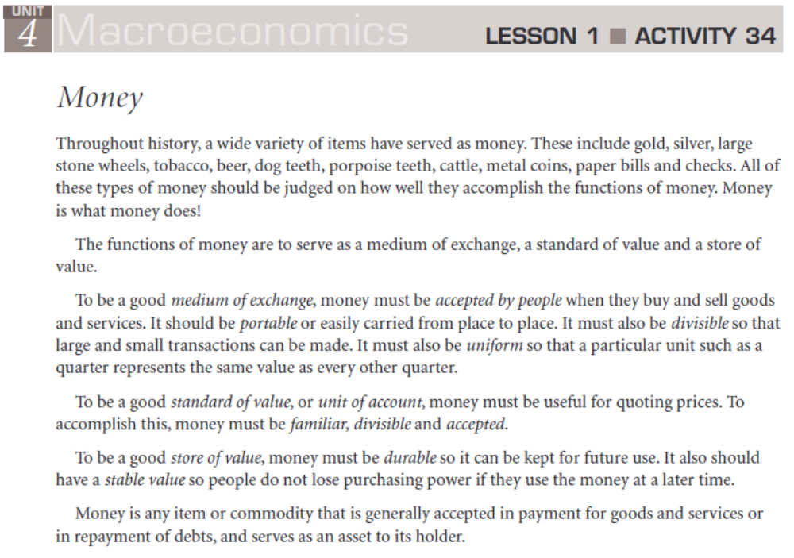

Name _________________________________________________ Hour _______________
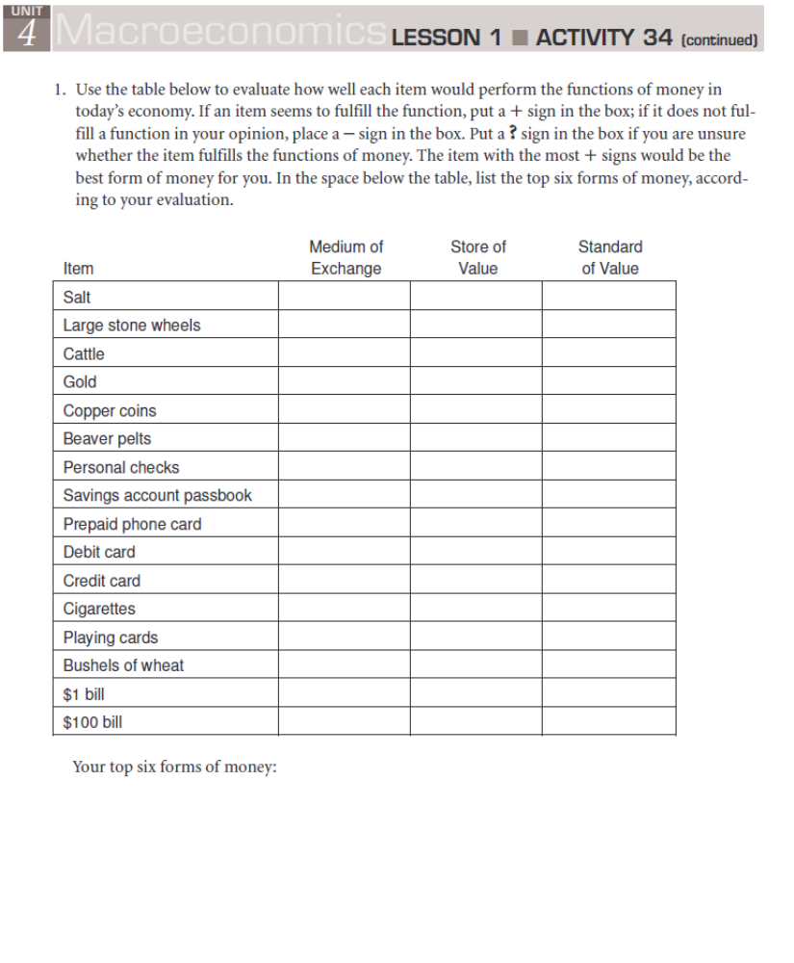

Name _____________________________________________ Hour _______________
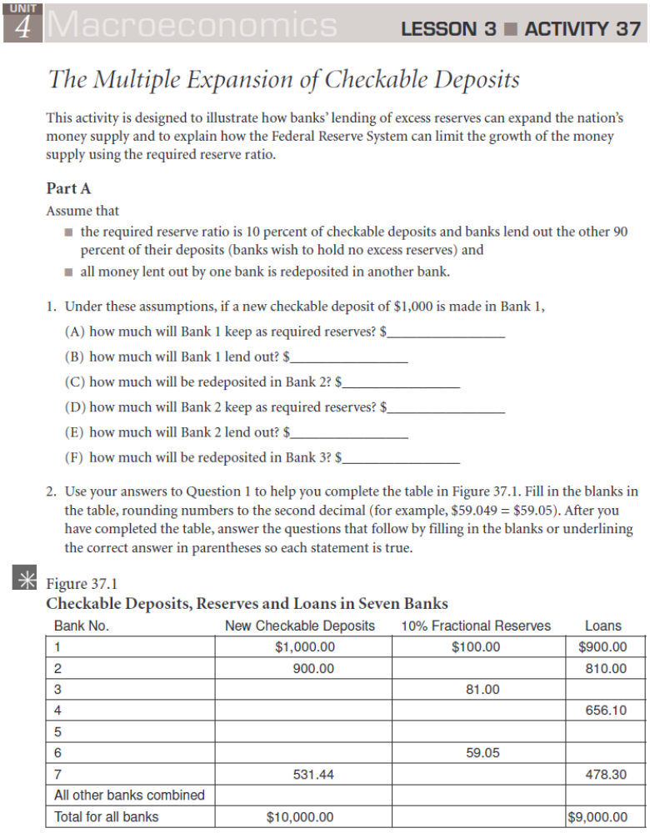

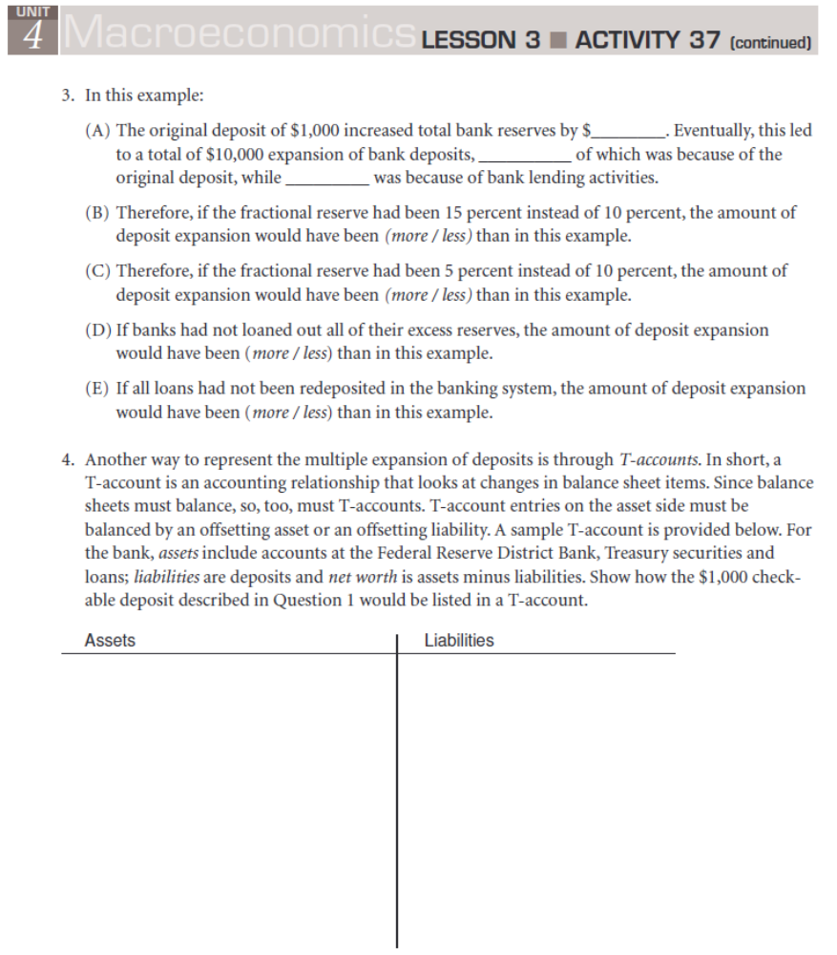

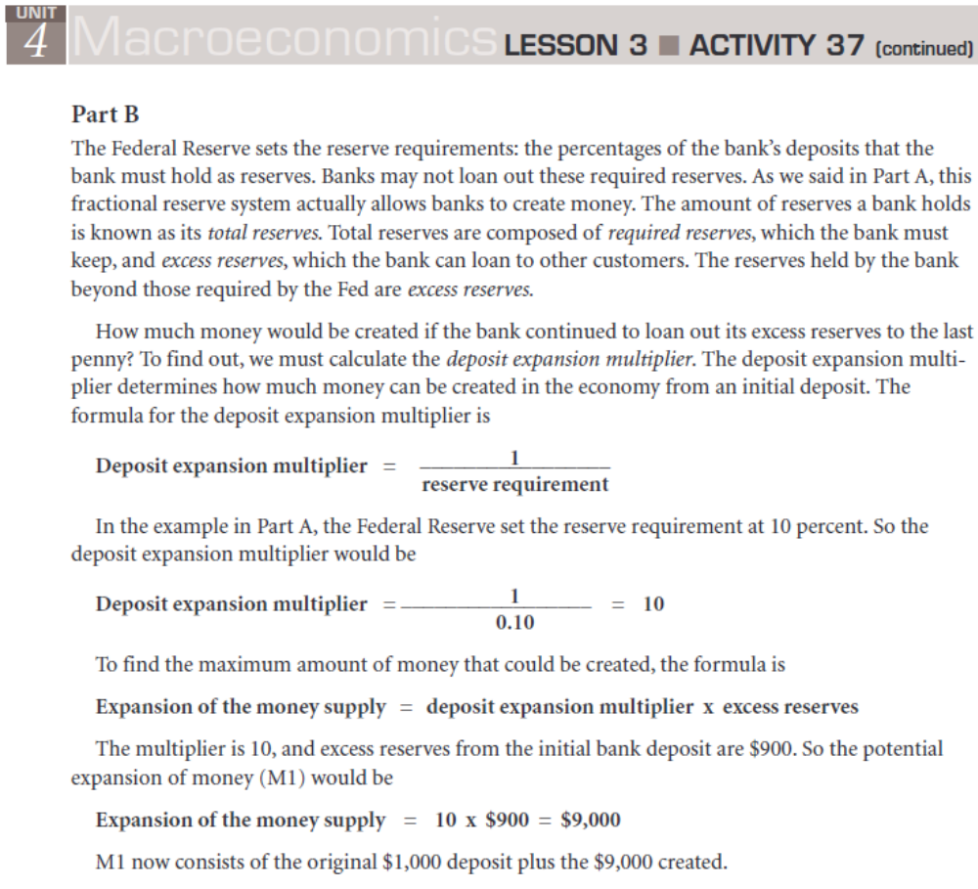

Name ____________________________________________________ Hour ___________


