Copyright Friendly Images
Pictures, clip art, photographs that may be downloaded and used in assignments, web pages & more
ClipArt | Google Images | Photographs | Questions 4 Image

Classroom ClipArt – clipart
CLKER – clipart (must pre-register… free)
Pics4Learning – photographs
Public Domain Images – photographs from online collections (Shutterfly, etc.)
…
Google Images – how to find copyright-clear images using Google
[ Do search ] > Search tools > Labeled for reuse
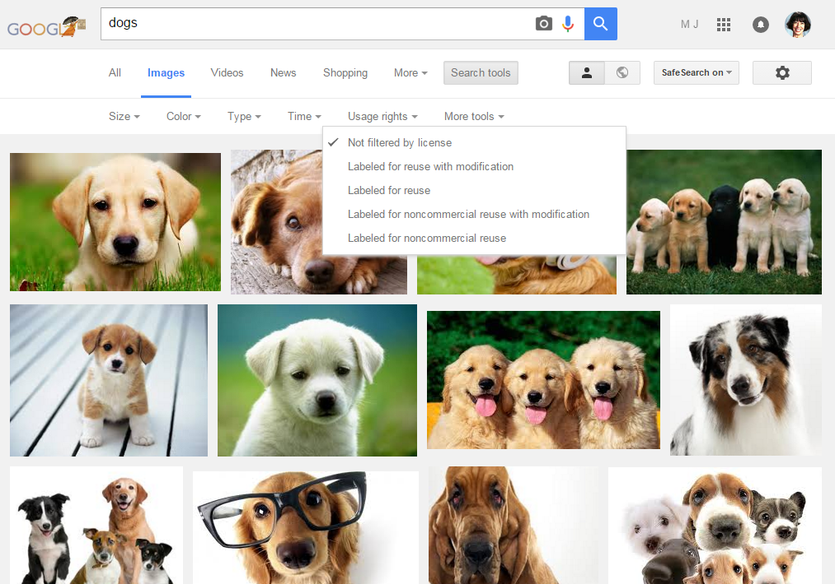
- .
…
Want to use an image but not sure of its copyright status? Try the link below for a step-by-step review Digital Image Rights computator [ http://dirc.vraweb.org/page_1.html ]
ClipArt | Google Images | Photographs | Questions 4 Image

With thanks to Rachel Smith, Pattengill LMSpecialist

