Norup Spirit Wear
Order online at http://www.goarmadillo.com/norup
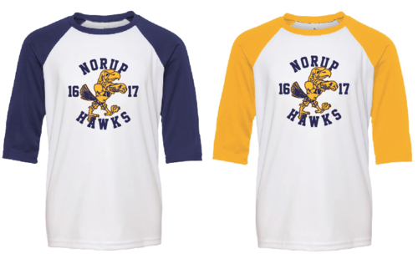
Orders will be accepted April 10 – April 28
Orders will be delivered to your Norup student by May 19.
20% of all orders will benefit Norup PTA

If you have questions please contact Liz Capuano at lizcapuano@gmail.com

