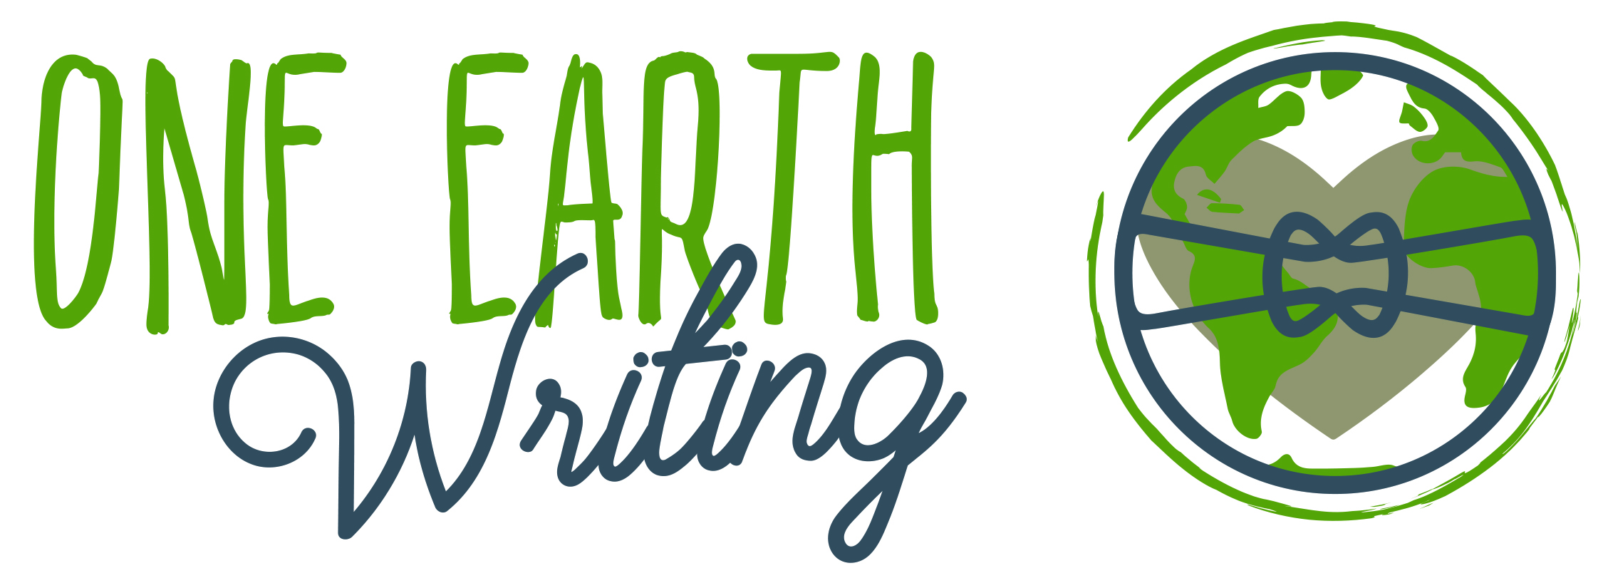

One Earth Writing Open Application Process for First Class of Ambassadors

FOR IMMEDIATE RELEASE August 4, 2016
CONTACT: Lynne Golodner (248) 376-0406, lynne@yourppl.com

HUNTINGTON WOODS, Mich. – One Earth Writing, a new nonprofit focused on building bridges of understanding between teens and tweens through creative, thoughtful writing, is accepting applications for its first class of ambassadors.

One Earth Writing Ambassadors are teenagers interested in exploring their writing talent through a lens of identity. They are open-minded individuals with a desire to lead who will participate in monthly writing workshops led by One Earth Writing founder and executive director Lynne Golodner as well as co-facilitate One Earth Writing workshops throughout the school year.

The commitment is November-May. Interested teens must write a one-page letter explaining why they are interested in participating and submit a sample of their best writing here: http://oneearthwriting.org/apply/.

Submissions are accepted between August 15 and October 10, 2016.

For information, call (248) 376-0406 or email lynne@yourppl.com.

One Earth Writing is a new non-profit created by author, writing instructor and entrepreneur Lynne Golodner, with a goal of bringing writing workshops to teens and tweens in schools, houses of worship and community centers as a way of building understanding between cultures, races and religions.

“I have always written about, and been fascinated by, the ways in which we share common ground,” says Golodner, the mother of four tweens/teens, owner of Your People LLC public relations firm and a renowned author and blogger at www.lynnegolodner.com. “Through One Earth Writing, I hope to transform the generation coming up with ideas of similarity and collaboration and stamp out bigotry one person at a time.”

One Earth Writing is guided by a board of directors that includes Detroit poet laureate M.L. Liebler, Pulitzer Prize-winning journalist Stephen Henderson, writer and writing instructor Maureen Dunphy, writer and editor Lisa Brody, attorney and blogger Alisa Peskin-Shepherd and American Federation of Teachers archivist and oral historian Dan Golodner.

ABOUT ONE EARTH WRITING
One Earth Writing seeks to build harmony in the world through writing workshops that connect tweens and teens from different communities and beliefs. Through storytelling, writing and one-on-one connection, One Earth Writing builds bridges of understanding, to see how similar all people truly are. We may come from different races, religions, ethnicities, national origins, sexual orientations or socioeconomic backgrounds, but at the core, we are more similar than we are different.

It is our goal at One Earth Writing to use story as a way of expanding world views, working with youth to change a generation’s perspective, so that one day, we may live in a world where we see similarity rather than difference.

One Earth Writing is in the process of qualifying for 501(c)(3) status and anticipates receiving official recognition later this year. Learn more at www.oneearthwriting.org.

Like us on Facebook: www.Facebook.com/OneEarthWriting

-30-

