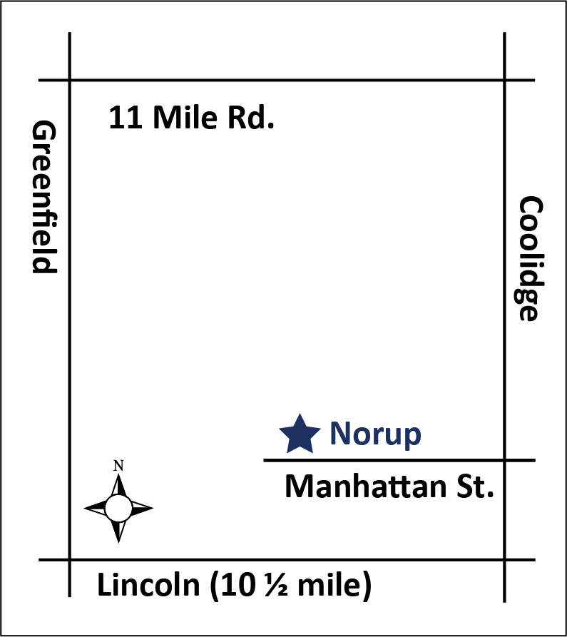Middle School

OPPORTUNITIES

June 26 – July 27

All classes held at Norup International School

14450 Manhattan, Oak Park, MI

The Berkley School District is pleased to offer the following courses for middle school credit and credit recovery:

**Language Arts Mathematics Science (Online Course) Social Studies (Online Course)**

6th Grade

7th Grade

8th Grade

6th Grade

7th Grade

8th Grade

6th Grade (Cells & Heredity)

7th Grade (Ecosystems)

8th grade (Physics)

6th Grade (Western Hemisphere)

7th Grade (Eastern Hemisphere)

8th Grade (American History)

Coursework will be delivered through face-to-face, direct teacher instruction for Language Arts and Math courses and online via the APEX online learning system (Science, Social Studies), assisted, facilitated and overseen by certified teachers. Course content will target specific, grade level curriculum standards. Students will be required to attend the entire duration of summer school to receive credit for the course. All coursework adheres to and is aligned with the standards and benchmarks of the State of Michigan and the Berkley School District.

**Schedule**

Students may take up to two classes. Students may choose the time slot during which they take the class(es):

8:00 AM - 10:15 AM and/or 10:20 AM - 12:30 PM. Classes are held Monday -Thursday. We will not meet Monday, July 3 and Tuesday, July 4. Spaces are limited for each time slot, so be sure to sign-up soon.

Lunch is not served on-site, however, breakfast will be available every morning for a small fee. Students eligible for free/reduced-fare lunch will also receive breakfast for free or at a reduced rate.

**Fees**

The fee is $160 per class. Any BSD student who

is eligible for free/reduced-fare lunch will receive

their first class at a reduced rate of $50/class. Additional classes are at the regular tuition rate.

Payment is due at the time of registration.

Students who choose to drop classes will be charged a $30 fee. No refunds will be granted after the second class period.

**Behavior/Attendance Policy**

Students are responsible for completing coursework during the time-span provided. Academic credit will not be granted if the student does not complete coursework, so attendance is of utmost importance. Students who have more than two absences will be at risk of not receiving academic credit.

Disruptive behavior on school grounds will not be tolerated, and may result in removal from the summer school program. Refunds will not be provided under these circumstances.

**Questions?**

**Email:** [**asarris@berkleyschools.org**](mailto:asarris@berkleyschools.org)

Middle School

O P P O R T U N I T I E S

BSD SUMMER SCHOOL REGISTRATION FORM

**FINAL DAY TO REGISTER IS JUNE 23**

Student name: Date of birth:

Address:

STREET CITY ZIP

HOME PHONE PARENT/GUARDIAN WORK/CELL PHONE NUMBER PARENT/GUARDIAN EMAIL ADDRESS (Please print clearly.)

Parent/Guardian Name:

Current School:  Anderson  Norup  Other (name of school and district):

Does your child have an IEP/504 Plan?  No  Yes (please explain):

**Language Arts Mathematics Science (Online Course) Social Studies (Online Course)**

❑ 6th Grade

❑ 7th Grade

❑ 8th Grade

❑ 6th Grade

❑ 7th Grade

❑ 8th Grade

❑ 6th Grade (Cells & Heredity)

❑ 7th Grade (Ecosystems)

❑ 8th Grade (Physics)

❑ 6th Grade (Western Hemisphere)

❑ 7th Grade (Eastern Hemisphere)

❑ 8th Grade (American History)

Middle School Counselor’s signature (required):

Please check the time slot(s) during which you would like to take class.

If taking one class, check one time slot; if taking two classes, check both time slots.

❑ 8:00 AM – 10:15 AM  10:20 AM – 12:30 PM

Please check applicable fees (see previous page for explanation): **BSD Students** **Non-BSD Students**

❑ One class: $160  One class: $180

❑ Two classes: $320  Two classes: $360

**BSD students only** - Tuition for first class waived (w/ $50 processing fee) if:

__ Student receives free/reduced-fare lunch

I understand the behavior/attendance policy of the BSD Summer School Program (on previous page):

Parent/Guardian signature: Date: _ ____

Student signature: Date: _ _

CHECK ENCLOSED payable to ***Berkley School District***

 VISA MC

CARD NUMBER: EXP. DATE: _____________

RETURN REGISTRATION FORM WITH PAYMENT IN FULL TO: BERKLEY SCHOOL DISTRICT

ATTN: SUMMER SCHOOL

14700 W. LINCOLN, OAK PARK, MI 48237

**FINAL DAY TO REGISTER IS JUNE 23**