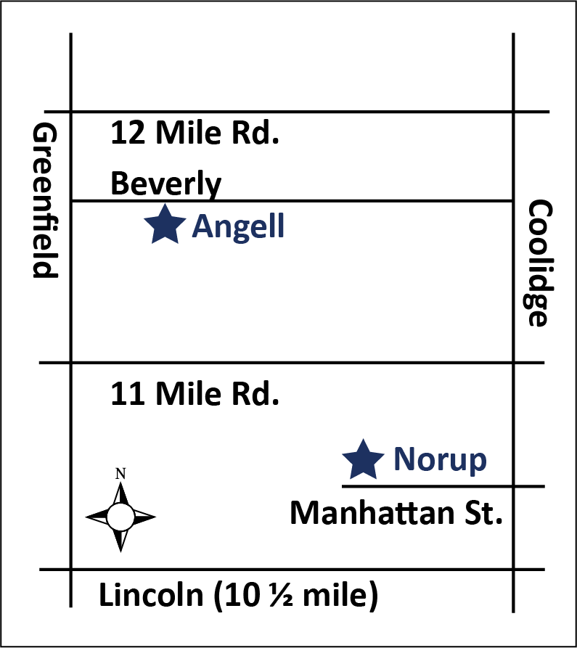
Elementary
Summer School Program
LANGUAGE ARTS & MATH
July 10-August 10, Monday-Thursday, 8:30-11:00 AM
Classes held at:
Norup International School (14700 W. Lincoln, Oak Park, MI 48237)
Angell Elementary (3849 Beverly, Berkley, MI 48072)
SUMMER SCHOOL: Language Arts & Math Program

The elementary summer school program is intended for students currently in Grades K-5 who need to maintain or grow in their achievement of the Berkley School District curriculum expectations in language arts and/or mathematics. Each class will be taught by certified, highly-qualified elementary staff members. Support and intervention strategies may be part of the basic instruction for select students as determined by summer school staff. Student’s individual records of achievement and assessments will be provided to the teachers prior to the beginning of the program so that instruction can be tailored to meet the needs of each student. Depending on enrollment, multi-grade sections may be organized to better meet staffing needs, and lessen the chance of a class not running due to low attendance. The summer program will be educational; however students will enjoy their time, learning through fun activities!

Schedule
All students are enrolled in the full morning program: 8:30 - 11 a.m., Monday through Thursday. There are no classes on Fridays. Parents may indicate their choice of location on the enrollment form but we cannot guarantee placement. Students are allowed to bring water bottles and a light snack.
Breakfast will be available every morning at 8:00 AM for
a small fee. Students eligible for free/reduced-fare
lunch will also receive breakfast for free or at a reduced
rate.
Fees
The cost of the program is $165 per child. If your family is eligible for free and/or reduced lunch benefits, please indicate that on the enrollment form. Once confirmed by district records, your fees for the program will then be fully waived. Additionally, tuition will be waived and paid for by the district’s At- Risk Grant Funds for select students who receive support services from one of our learning specialists. Not all students who receive services will qualify for the grant funding. Please speak with your learning specialist or building principal to see if your child qualifies.

Behavior/Attendance Policy

Full time attendance is expected for the duration for the program. Students with 5 unexcused absences may be dropped from the program. Parents are responsible for all transportation to and from the school. Students are to be picked up by an adult upon dismissal from the class at 11 a.m. and should only be dropped off before 8:30 a.m. if he/she plans to attend the breakfast program. The Berkley School District Student Code of Conduct is fully applicable during this summer school experience.

Questions?
Please call: 248-837-8640 or EMAIL: cmcvean@berkleyschools.org

FINAL DAY TO REGISTER IS JUNE 16

Elementary Summer School Registration Form
FINAL DAY TO REGISTER IS JUNE 16

Student Name: Date of Birth: / /

Address:
STREET CITY ZIP

HOME PHONE WORK/CELL PHONE NUMBER EMAIL
Parent/Guardian Name:
Alternate contact person/phone# in case of an emergency: _________________________________________
Student Currently Attends:  Angell  Burton  Norup  Pattengill  Rogers
Student Currently is in (2016-17):  Kindergarten  1st Grade  2nd Grade  3rd Grade  4th Grade  5th Grade
(Elementary Summer School is not provided for current Y5s students)
Student’s Current Teacher (2016-17): ______________________________________________________________
Does your child have an IEP/504 Plan?  No  Yes (please explain):
Will your child need to take medication during school hours or have any medical needs? Please explain.
__________________________________________________________________________________________
Indicate below which area(s) your child needs additional support. Check all that apply:

❑ Reading  Writing  Mathematics

Please select the school where you would prefer your child attend the Summer Program:

❑ Norup International School  Angell Elementary

FEE: $165/child
FREE if:
❑ My child/family is eligible for free/reduced lunch
❑ My child receives services from the learning specialist at his/her school - Please attach signed voucher from the learning specialist

I understand the behavior/attendance policy of the BSD Summer School Program (on previous page):

Parent/Guardian signature: Date: / /

CHECK ENCLOSED payable to Berkley School District

VISA MC
CARD NUMBER: EXP. DATE: / /

RETURN REGISTRATION FORM WITH PAYMENT IN FULL TO: BERKLEY SCHOOL DISTRICT
ATTN: SUMMER SCHOOL, 14700 W. LINCOLN, OAK PARK, MI 48237

