Enzymes
Directions: Enzymes are special proteins found in biological systems (like in our bodies!). Their job is to “speed up” chemical reactions, or somehow help chemical reactions happen. When it comes to food molecules, some of the most common chemical reactions involve breaking down large molecules (macronutrients) into smaller molecules. Use the models below to answer questions about these chemical reactions.
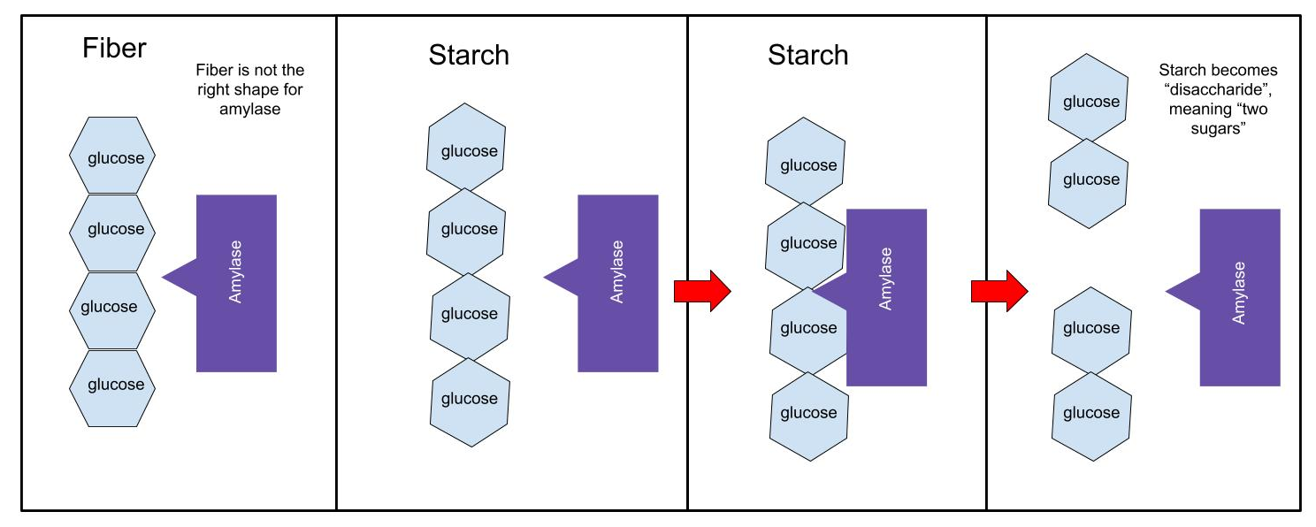
- There are many enzymes that can carry out the chemical reactions to break down starches. Amylase (above) is one of the most common. Using the model above, describe how amylase can break down starches, but not fiber.

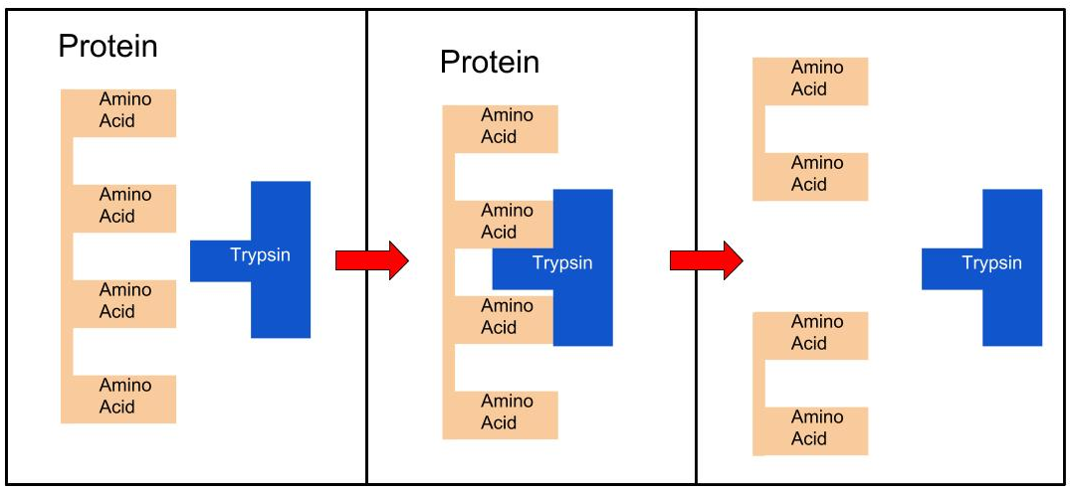
- There are many enzymes that can carry out chemical reactions to break down proteins. Trypsin is one of the most common enzymes that breaks down proteins in a chemical reaction. Using the model above, explain how trypsin breaks down proteins.

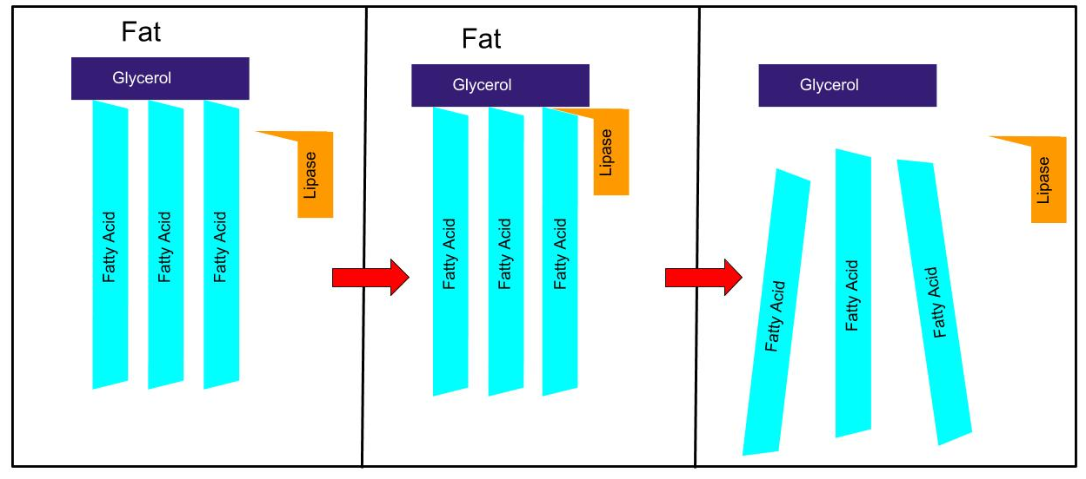
- There are many enzymes that can carry out chemical reactions to break down fats. Lipase is one enzyme that breaks down fats in chemical reactions. Fats are large molecules made up of three fatty acids and glycerol. Using the model above, explain how lipase carries out this chemical reaction.

- It is important to realize that macronutrients are large molecules. When they are broken down, a chemical reaction has occurred, which produces completely new molecules. Which of the four macronutrients get broken down during digestion? That is, which macronutrients undergo chemical reactions in the digestive system?

