Lynx / Hare Graphing Guide
The following graph is a record of the populations of Canada lynx and snowshoe hare from 1820 to the 1920s, recorded by the Hudson’s Bay Company, a company which paid trappers for pelts. Canada lynx feed mainly on snowshoe hare.
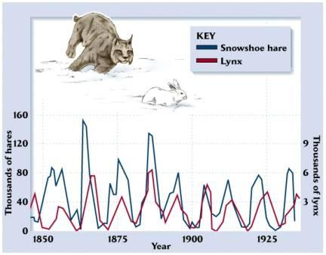

Using this graph, answer the following questions:
- Let’s start by looking at the x axis. What are the numbers representing? ____________________

- On the left side Y axis, what do the numbers represent? _______________________________

- On the right side Y axis, what do the numbers represent? _______________________________

- Looking at just the line for hares.
  - What is happening to the hare population when the line goes up?
________________________________________________________________________________________________________________________________________________
  - When the line goes down?
________________________________________________________________________________________________________________________________________________
- Looking at just the line for lynx.
  - What is happening to the lynx population when the line goes up?
________________________________________________________________________________________________________________________________________________
  - When the line goes down?
________________________________________________________________________________________________________________________________________________
- Let’s look at the lynx and hare lines together.
  - What observations can you make when looking at both lines together? ________________________________________________________________________________________________________________________________________________________________________________________________________________________________________________________________________________________________

  - Why do you think they do not go up and down at the exact same time?
________________________________________________________________________________________________________________________________________________________________________________________________________________________________________________________________________________________________

<http://denalibiomeproject.wikispaces.com/file/view/lynx-hare.jpg/73213523/lynx-hare.jpg>

