Interpreting Data: Largemouth Bass and Dead Trees

Some people think that dead trees that fall into lakes are an important resource for largemouth bass that live in the lakes. Scientists tested this hypothesis by counting the number of dead trees that were found in three different lakes. Then they measured how quickly the largemouth bass were growing in each lake. Healthier individuals tend to grow faster than unhealthy individuals. This means healthy individuals have a larger growth rate. Their findings are shown in the graph below.
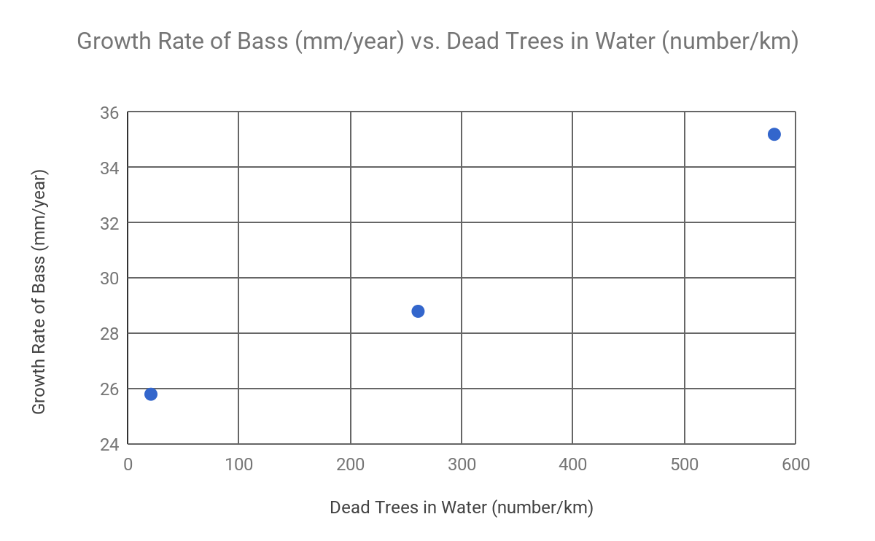

Adapted from: Schindler, D., Geib, S. & Williams, M. Ecosystems (2000) 3: 229.

Explain the relationship, as shown on the graph, between the growth rate of bass and the number of dead trees.
____________________________________________________________________________________________________________________________________________________________
Does the data provide evidence to support the hypothesis that dead trees are an important resource for largemouth bass? Explain your ideas.
__________________________________________________________________________________________________________________________________________________________________________________________________________________________________________
What do you think might happen to the largemouth bass if the trees bordering the lake shoreline were to be cleared to build cottages?
__________________________________________________________________________________________________________________________________________________________________________________________________________________________________________
How would this change likely affect the population of bass? Why?
__________________________________________________________________________________________________________________________________________________________________________________________________________________________________________

