Unit 6.1 Lesson 3: Water Systems

Lesson 3 Activity #1
A puddle formed on grass after a heavy rainfall. But now the rain has stopped and the sun is out. In a few hours, the puddle will completely disappear. The model below uses arrows to show where the water in the puddle will go. Some water will go into the ground, and some water will go into the atmosphere. Modify the model to show why the water disappears.

For your model
- Draw the energy driver of water going into the ground, use ---->
- Draw the energy driver of water going into the atmosphere, use
- Add to the legend the names of the added energy drivers.

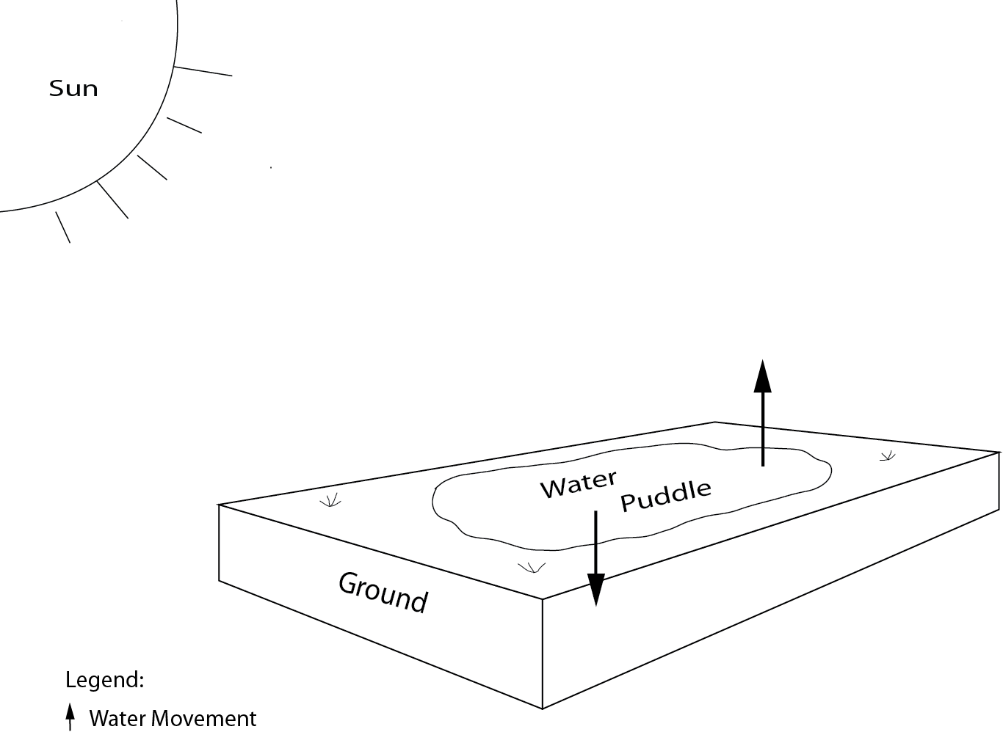

Legend
Water movement
__________

_________

Part II.
Describe what your model shows. Be sure to describe what is causing the water to move into the atmosphere and into the ground, and the name of each process.
__________________________________________________________________________________________________________________________________________________________________________________________________________________________________________
Part III.
Imagine a heavy rainstorm occurs late (2 a.m.) in the evening. Predict how water movement in the model might change during the night. How does your model support your prediction?
__________________________________________________________________________________________________________________________________________________________________________________________________________________________________________
Lesson 3 Activity 2
You watered the plant in the pot and placed it outside in a sunny spot.
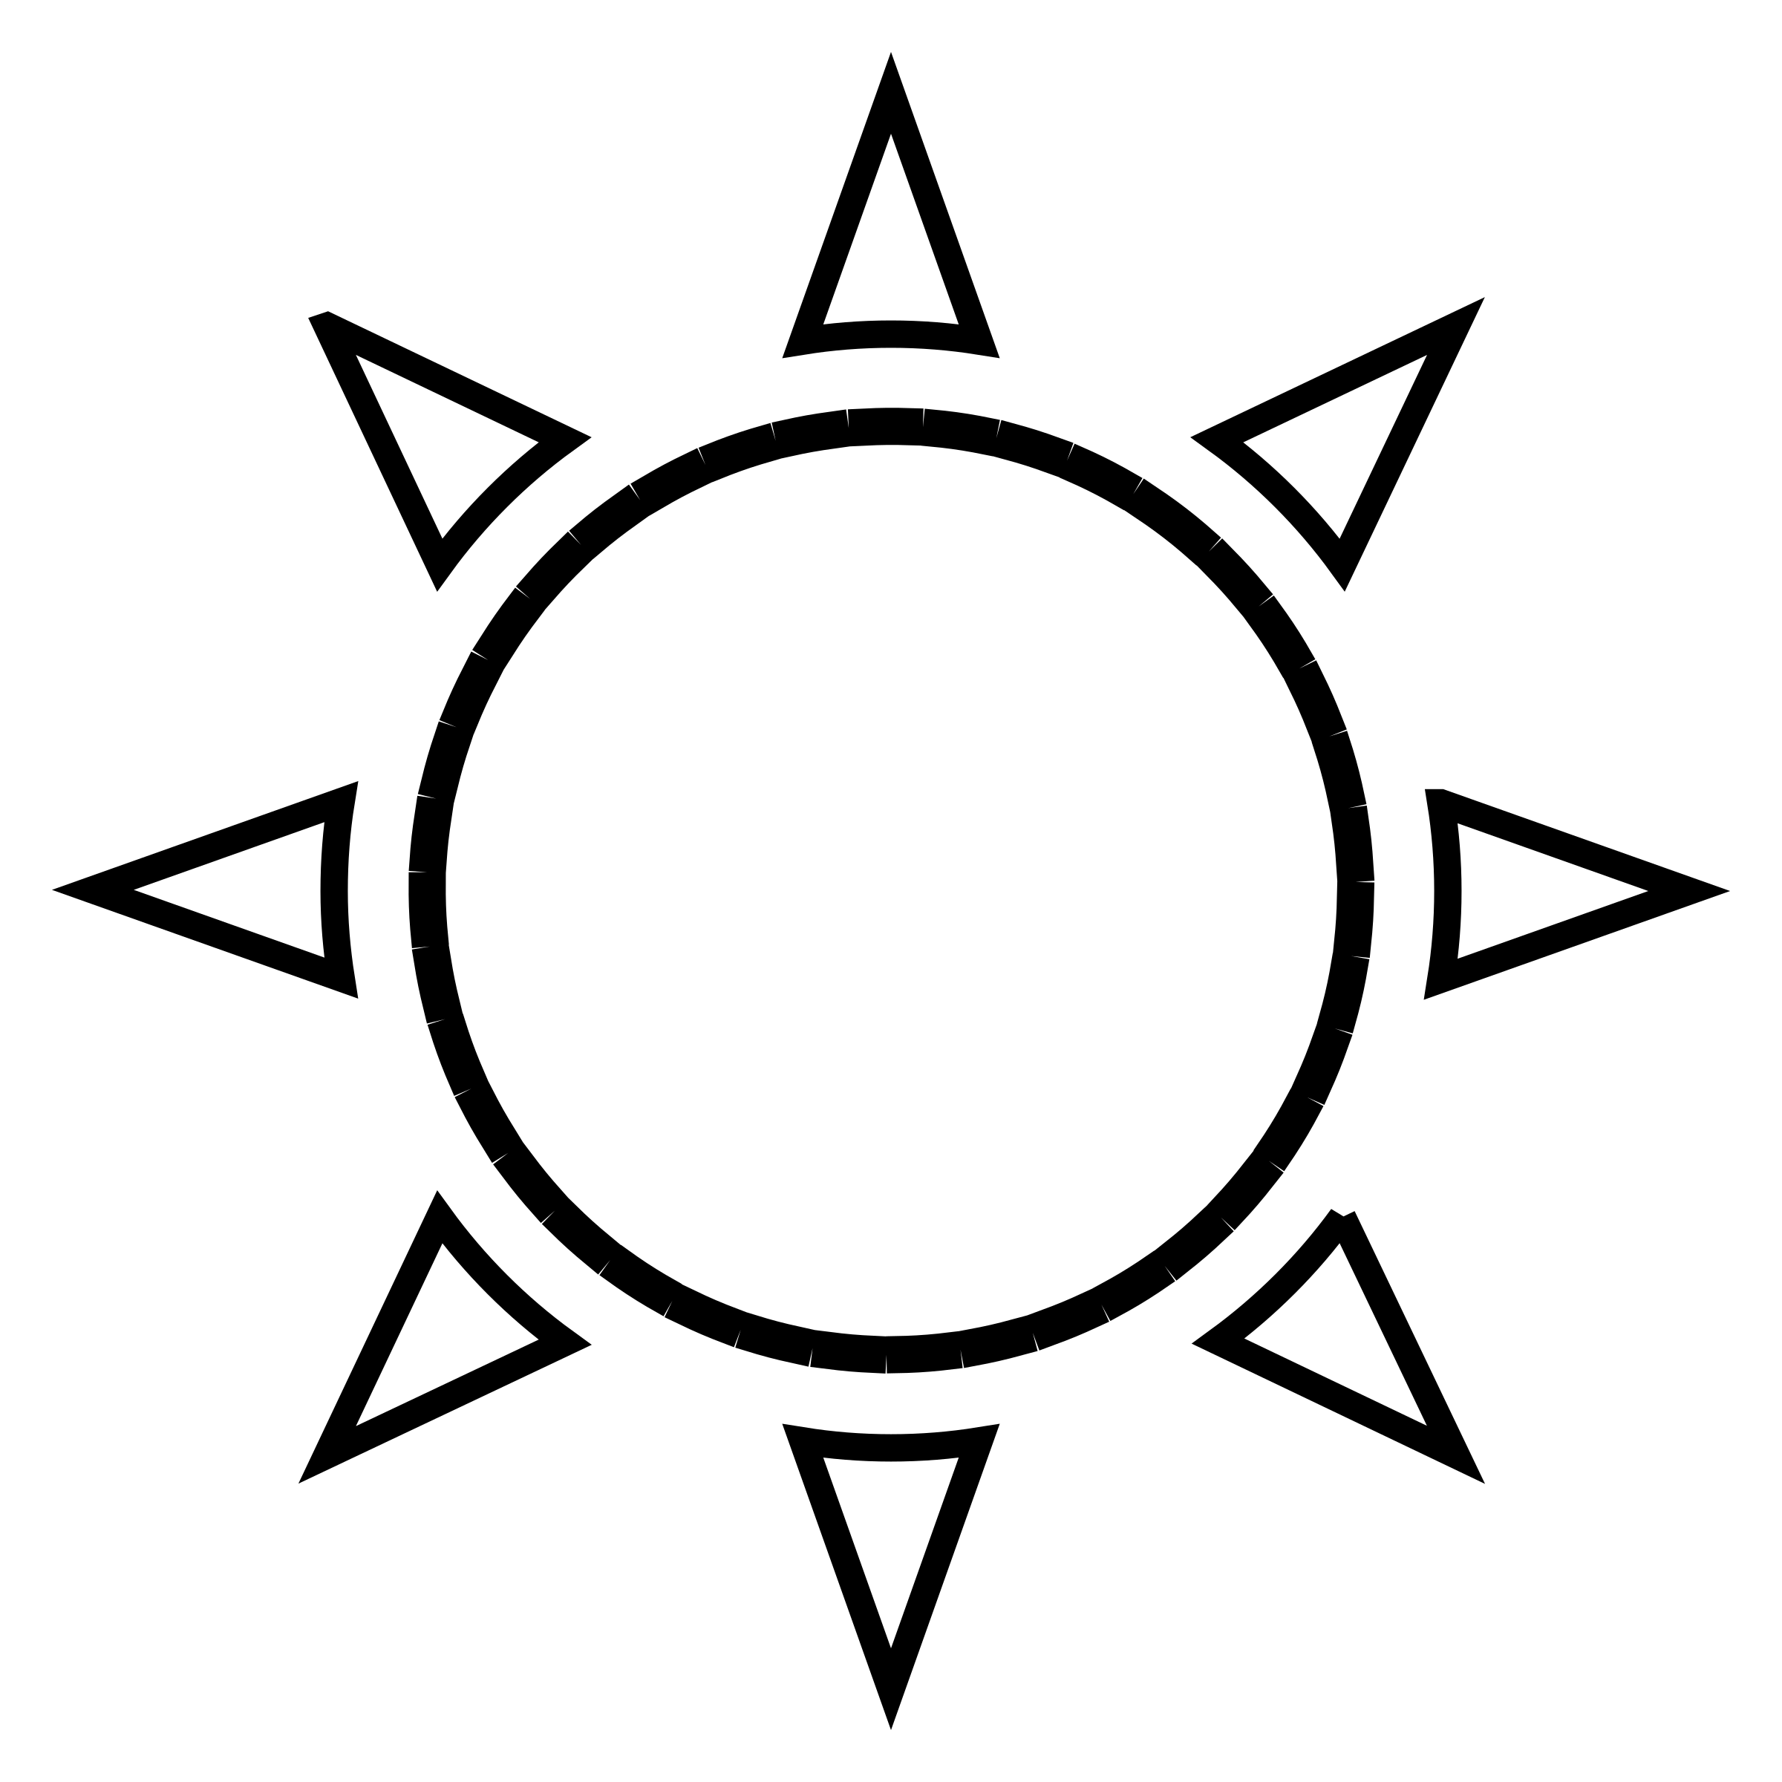
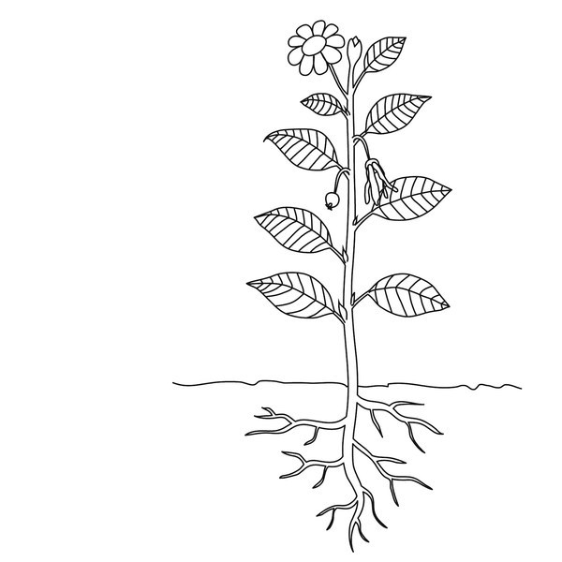
Legend:

1. Label the essential parts of your model. In your legend:
a. the movement already shown in the plant. Name that movement (process) include the symbol in your legend. Use
b. show the energy driver and how it interacts with your model. Name that energy driver and use -----> as your symbol.

2. Describe what your model shows. Your description should include:
- What is causing the water to move.
- The name of the process that is taking place.
- The state of the water (solid, liquid, gas) at the beginning and end of the process.
__________________________________________________________________________________________________________________________________________________________________________________________________________________________________________

