Math 7
CMP-3 Unit Review
Shapes and Designs
Name:_______________________________________________________________
Date:________________ Hour:_________
- Draw and label the parallelogram with the following properties.

2 angles = 65°, 2 angles = 115°, and side 2 sides = 1 in and 2 sides = 2 in.

- Is it possible for a triangle to have a 44° angle, a 33° and a 104° angle? Explain why or why not.

- Use rectangle ABCD with diagonal DB. Find the measure of the angle marked x. Show your work.
SHOW ALL WORK
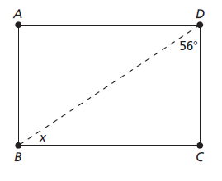
- Draw triangle ABC with AB = 4 cm, BC = 5 cm, and .

- Draw the following angles.

a. 40° b. 135°

c. 98° d. 70°

Decide whether the given statement is true or false. Give explanations or sketches to support your answers.

- You will always be able to draw two different triangles using side lengths of 3, 4, and 5.

- Any two quadrilaterals that have sides of the same lengths will be identical in size and shape.

SAMPLE
Two quadrilaterals with side lengths measuring 5, 7, 9, and 11 will be the same size and shape.

- All parallelograms are special kinds of squares.

- You can have a quadrilateral with the side lengths 5 cm, 7 cm, 8 cm, and 20 cm.
- In the diagram, line L₁ is parallel to line L₂.

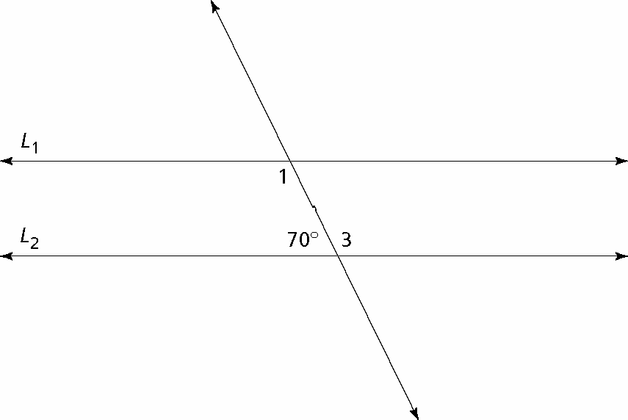

a. What is the measure of ∠ 3? Explain how you found your answer.
b. What is the measure of ∠ 1? Explain how you found your answer.

Use an angle ruler to measure each angle.

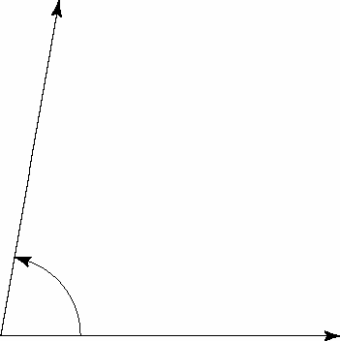

11b.

- One of the most common places we see angles is on the faces of clocks. At the start of each hour, the minute hand is pointed straight up, at the 12. On the clocks below, mark where the minute hand is at the start of an hour as one side of an angle. Sketch the angle formed by the minute hand at the time shown, and give the measure of the angle.

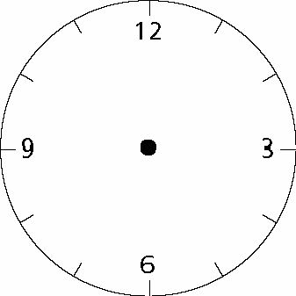 25 minutes ___________________

Use the given data and what you know about relations among sides and angles to find the lengths and angle measurements of all sides and angles in the figure.

- parallelogram

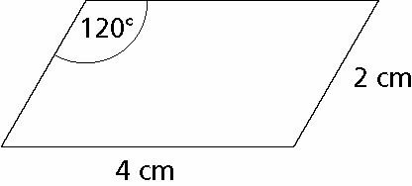

- An isosceles triangle has two 50° angles. What is the measure of the third angle? Explain how you found your answer. Use complete sentences.

15. Suppose two angles are supplementary and one of them is 48°. What is the measure of the other angle? Draw the angles to prove it.

- Suppose two angles are complementary and one of them is 55°. What is the measure of the other angle? Draw the angles to prove it

- Bob has sketched an equilateral triangle. The sum of the lengths of the sides is 10.5. What is the length of each side of Bob’s triangle? Explain your reasoning. Use complete sentences.

- Use the triangle below to answer the following questions.

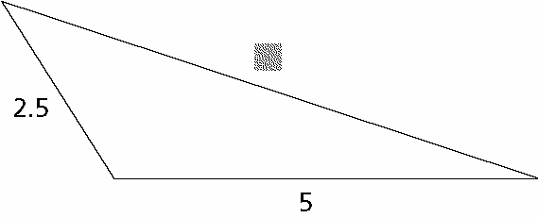

a. Alex estimates that the unknown side length is about 5. How do you think Alex’s estimate compares with the actual length? Explain your reasoning.

b. Jennifer estimates that the unknown side length is about 8.5. How do you think Jennifer’s estimate compares with the actual length? Explain.

c. Use what you have learned about making triangles with polystrips to estimate the length of the unknown side. Explain why you think your estimate is close to the actual length.

