Name_______________

Water Study Guide: Due _______________
Water Test: ____________

Outline:
Lesson 1
- How do humans use water?
- How do humans change water moves? Where is water in our community?

Lesson 2
- Gravity is an energy driver for water movement.
- Water moves through different materials at different rates
- Different elevations affect flow of water due to gravity
- Some surfaces will allow water to soak in and others will not.
- The shape of the land can influence where water flows and how quickly it moves (rate)

Lesson 3
- Transpiration is when water exits as a gas from the leaves of plants.
- Sunlight is an energy driver for water movement.
- Evaporation occurs when a liquid changes to a gas due to a rise in temperature due to heat.
- Condensation forms when a gas changes to a liquid.

Lesson 4
- Solids, liquids, and gasses are different states of matter.
- Particle movement, relative spacing, and energy are different for each state of matter.

Lesson 5
- Thermal energy is how quickly atoms and molecules move.
- Changes in matter are due to an increase or decrease in thermal energy (freezing, melting, evaporation, condensation)
- The sun is an energy driver for changes in states of matter.

Lesson 6
- The water cycle is a continuous movement of water among land, ocean, and atmosphere.
- Humans can impact the water cycle, slow down or speed up, but cannot stop the water cycle.
- Water can move through the water cycle in many different pathways.
- The energy drives for the water cycle are the sun and gravity.

Lesson 7
- Constraints- the goals we want the solution to meet as much as possible. (Must haves)
- Criteria- what we will accept once the constraints are met. (wish and wants)
- Constraints and Criteria are always measureable.
- When we have clear and well defined criteria and constraints, you get a more successful solution.
- Useful criteria and constraints must be based on scientific principles that are relevant to the problem.
- Useful criteria and constraints are also based on other relevant knowledge (cost, materials, safety, human/environmental impact)

Review Questions. Answer in complete sentences and use the diagrams boxes to model your explanations. Label all components, seen and unseen.

- Briefly define the following terms.

Infiltration- __________________________________________
Runoff-______________________________________________
You are given two different materials that water interacts with as precipitation. They show infiltration and runoff. What would you expect to see/observe? Draw a diagram below to help.
________________________________________________________________________________________________________________________________________________________________________________________________________________________________

- Does water move differently when it rains on the mountains as opposed to when it rains on flat lands? What would you expect to observe? Draw a diagram below to help.
________________________________________________________________________________________________________________________________________________________________________________________________________________________________________________________________________________________

- Think back to the Wet Jeans experience at the beginning of lesson 3. The wet jeans were left outside on sunny day and an hour later they were dry. Explain the processes involved and the energy driver to cause the jeans to dry.

________________________________________________________________________________________________________________________________________________________________________________________________________________________________________________________________________________________

- Think back to the rainmaker experiment where we sealed two bottles of water and set one under a lamp and the other in a dark closet. What would you expect to see with the bottle under the lamp and then the bottle left in the dark? How will the water move, if at all? What causes the water to move, if at all?

________________________________________________________________________________________________________________________________________________________________________________________________________________________________________________________________________________________

- Think back to the Celery investigation. We placed a piece of celery in colored water, covered the lid with saran wrap so it would be sealed, and left it under a lamp for 24 hrs. The next day we noticed that the celery’s vein had the same color of the dye water and that when we measure the water in the cup, it was slightly less than what we started with.

Using the scientific processes, explain where the water went and what the cause of this water movement was.

________________________________________________________________________________________________________________________________________________________________________________________________________________________________________________________________________________________

- Water can be in 3 different forms of matter. Name them.

_________, ____________, and ________________.

- Describe the energy level, particle movement and particle spacing for each state of matter. Draw in the boxes below what the particles would be doing in a table top, soda in a glass (ignore the glass particles, and then the helium inside a balloon.

________________________________________________________________________________________________________________________________________________________________________________________________________________________________________________________________________________________
________________________________________________________________________________________________________________
Helium
Soda
Table top

- For changes in states of matter, there has to be a change in thermal energy. Imagine your car sitting overnight on a cold night. When you get in the car in the morning, the front windshield is clear has frozen spots of dew on it. You turn on the heat and notice the frozen dew has started to drip down and then as you are driving to work the windshield is completely clear of water. Explain what is happening to the water at each stage, using the ideas of thermal energy and particle movement. Also, name the process that each stage of water is changing to as it goes from the frozen drop of dew to it disappearing off your windshield.
________________________________________________________________________________________________________________________________________________________________________________________________________________________________
________________________________________________________________________________________________________________________________________________________________________________________________________________________________________________________________________________________

- Name the reservoirs in the model below ______________________________________________________
- Where would you expect runoff, evaporation, infiltration, ground water movement, condensation, precipitation to occur? Label the diagram with these processes.

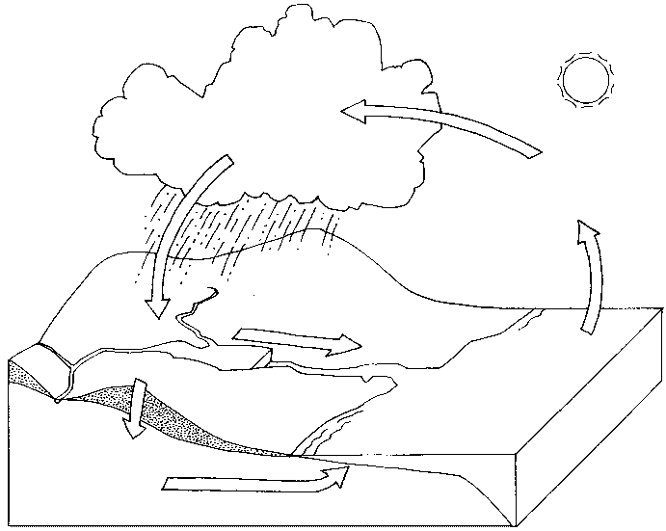

- Imagine you are a drop of water in this diagram. You are starting as a droplet in the cloud. Explain how you would interact with the model to find your way to three different reservoirs. Define the process that would get you there. (this is similar to My Incredible Journey activity we did as a class)

________________________________________________________________________________________________________________________________________________________________________________________________________________________________________________________________________________________
________________________________________________________

- Egg drop lab: Read the following description and decide what is a constraint:

Teams will work together to design and container with a parachute that can carry an egg safely to the ground. The goal is to have the slowest time, safest landing and egg intact. The container must be no bigger than 20 cm x 20cm x 20cm. The maximum mass cannot exceed 800 g. Containers need to be homemade and easily opened.

What would you consider to be criteria?

