Unit 2, Part 2: Measurement of Economic Performance

Exam Date:
Multiple Choice and Graphing Tests: Thursday, February 25

Advanced Placement Macroeconomics Unit 2 Part 2- Overview - Measuring Economic Performance

Part 2 Test (Within a day or two)
Both Multiple Choice and Graphing Tests: Thursday, Feb 25th

Textbook Pages
1. Chapter 7 page 134, "Inflation" to the end of the chapter
2. Chapter 2, pages 38 - 41 The Circular Flow Model
3. Chapter 4, pages 75 - 77 "The Circular Flow Revisited" up to but not including "Federal Finance"

Graphs for Graphing Test
Key Graphs 1 - 11
Note: For the Circular Flow Model, you will be given an image of the model with some terms given and some missing. You will be asked to fill in the missing terms correctly.

Key Concepts for Part 2 Test
Inflation, price indices, CPI, GDP Deflator, adjusting for inflation, depreciation, personal income, Circular Flow, households, businesses, government, international sector, gross domestic product, inflation

Reading Due Dates. GO FOR UNDERSTANDING!
Outline Collection - Monday, February 22nd - Chapter 7, page 134 the short section on "Inflation" and "Meaning of Inflation," page 138 "Who is hurt by inflation" to page 140 "Does Inflation Affect Output," and page 141 "Hyperinflation"

Crucial Activities for Part 2 Test
1. Outline: Chapter 7, page 134 the short section on "Inflation" and "Meaning of Inflation," page 138 "Who is hurt by inflation" to page 140 "Does Inflation Affect Output," and page 141 "Hyperinflation"
2. Macroeconomics Lesson 3 Activity 15 Who is Hurt / Helped by Inflation?
3. Macroeconomics Lesson 2 Activity 11 Measuring Price Changes
4. Macroeconomics Lesson 3 Activity 13 Price Indexes
5. The Circular Flow – A model of economic activity
6. Getting into the flow activity
7. Discuss Getting into the flow activity
8. Macroeconomics Lesson 1, Activity 10 - Understanding the Circular Flow of the Marcoeconomy
9. Practice Test

Name ________________________________________________________________ Hour _____________
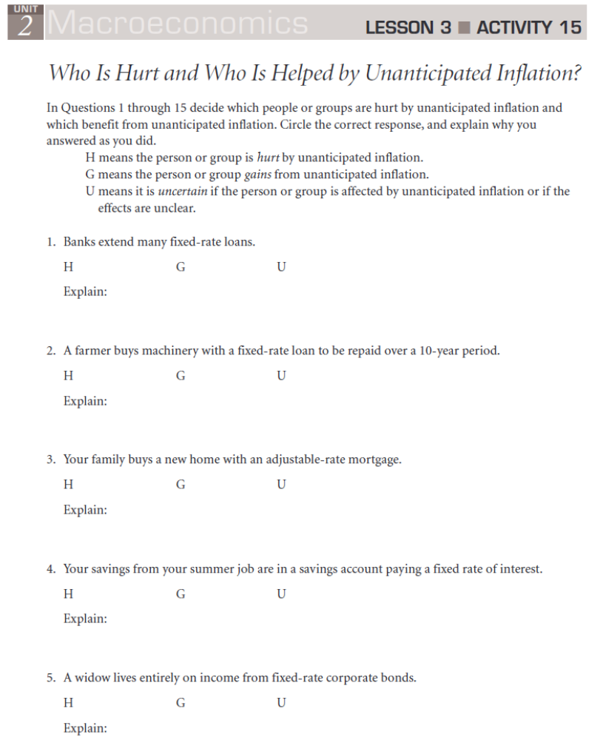

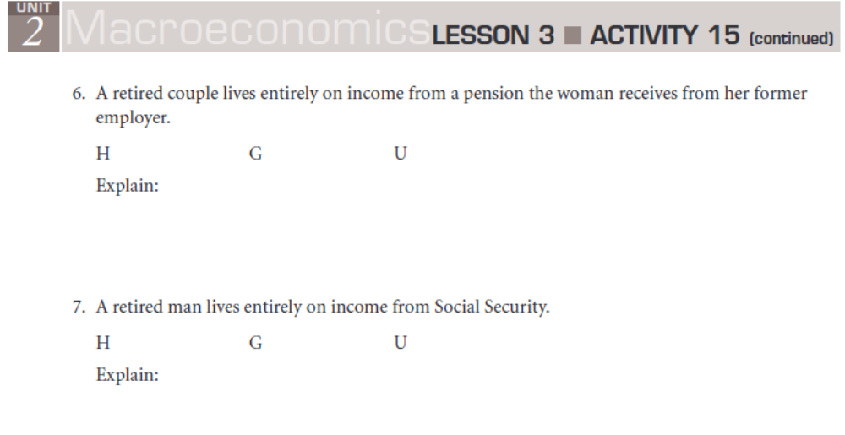
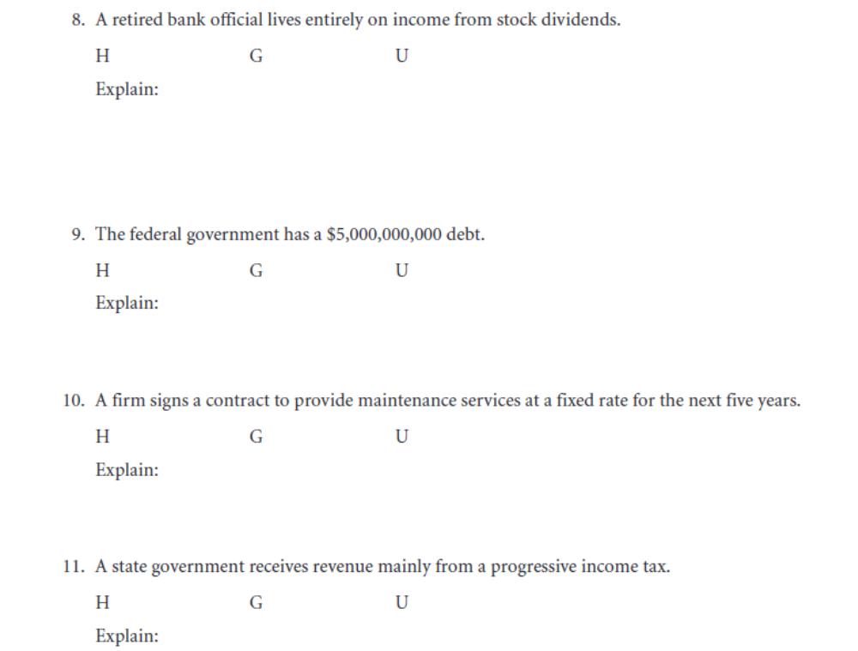

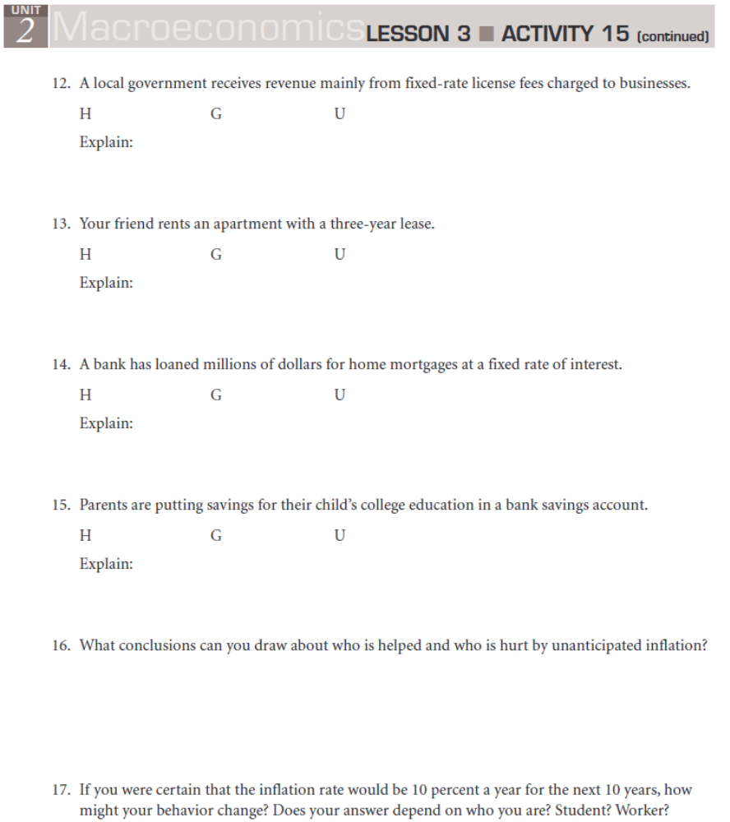

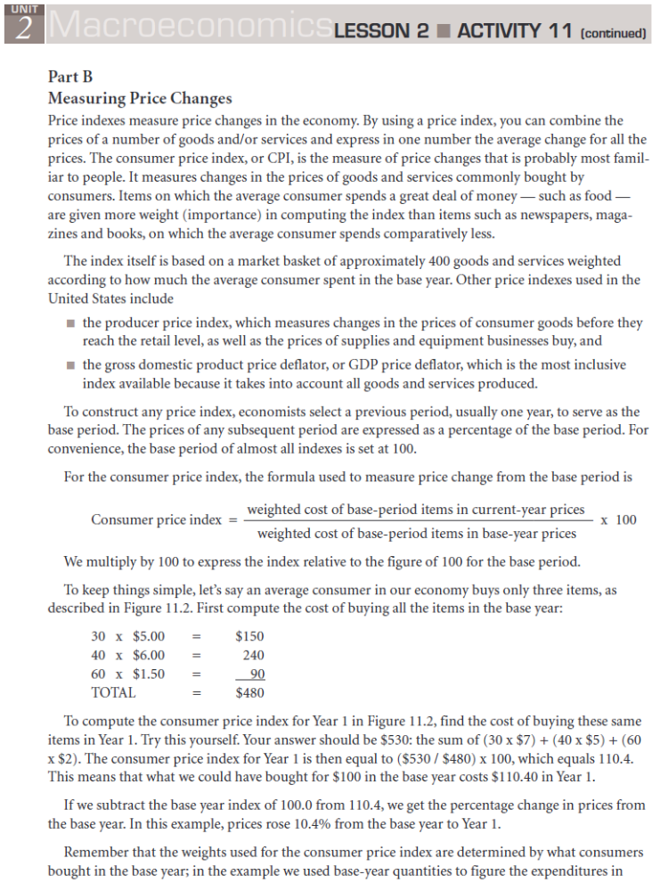

Name _______________________________________________________ Hour __________________
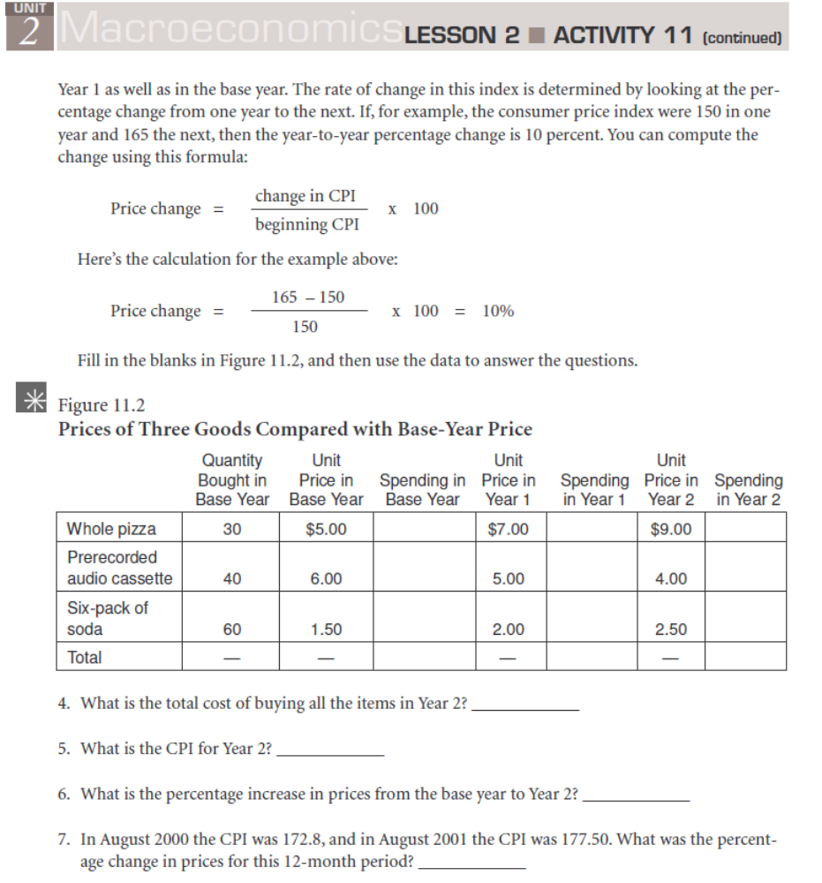

Name _____________________________________________________ Hour ____________________
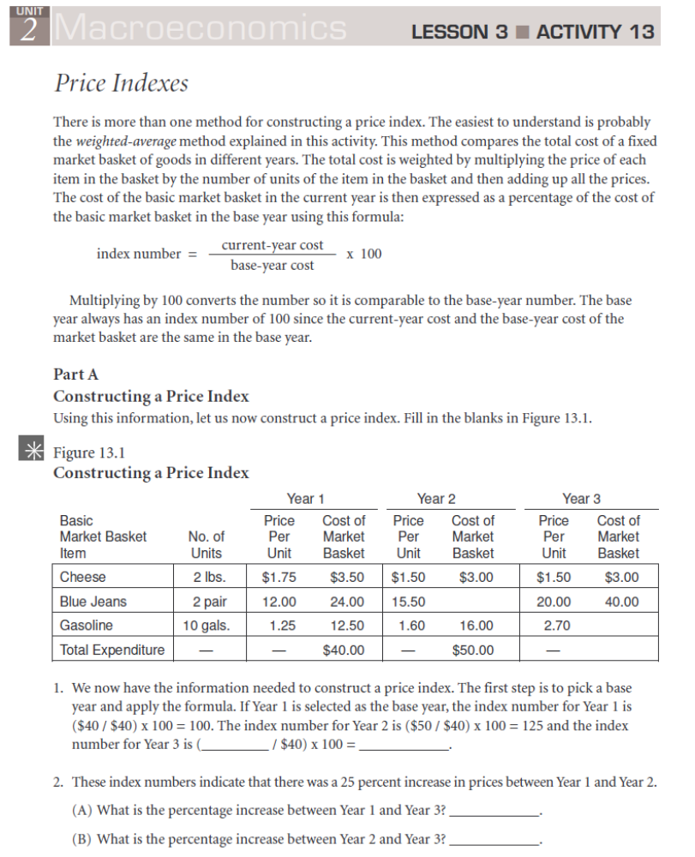

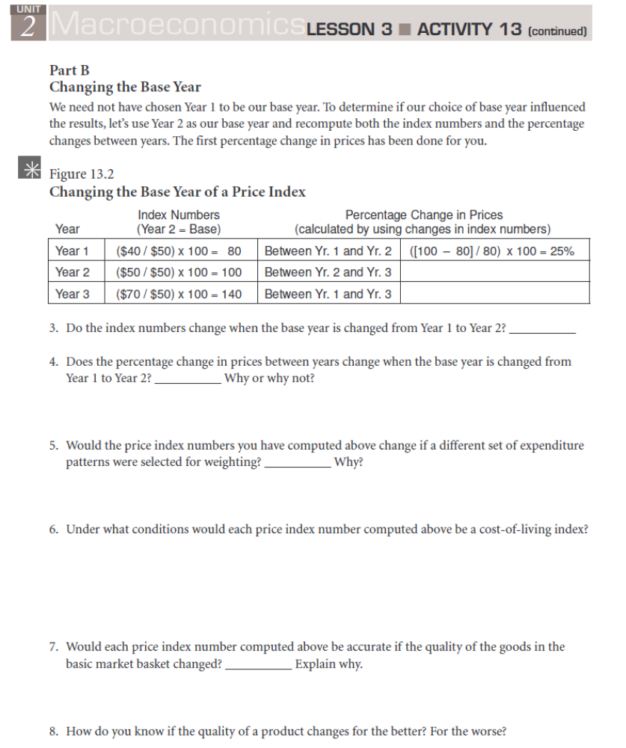

Name _________________________________________________________________ Hour ___________
The Circular Flow – A model of economic activity
I. Two Markets in the circular flow
A.

B.

II. Two Actors in the simple circular flow
A.

B.

III. 3rd actor in the expanded circular flow: _________________________
A.

B.

C.

D.

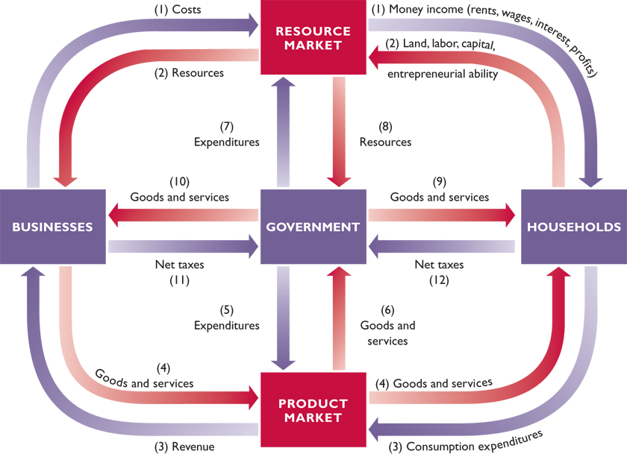

Name __________________________________________________________________________ Hour _______________________
Getting into the flow
Directions: Read the story below. Then, get the characters and things from the story into the flow by filling out the table at the bottom, writing each bolded term from the story next to the term that it is equal to. For terms for which there is no specific bolded word that should be substituted, just re-write the term from the circular flow diagram (For example, "Resource Market" will still just be "Resource Market," so I left it as "Resource Market" as an example.)

Story: Mr. Vincent works as a mechanic for "Run-Smooth Auto-repair." With some of the money he makes, goes to ABC Warehouse and buys a new LCD TV made by Sony Corporation.
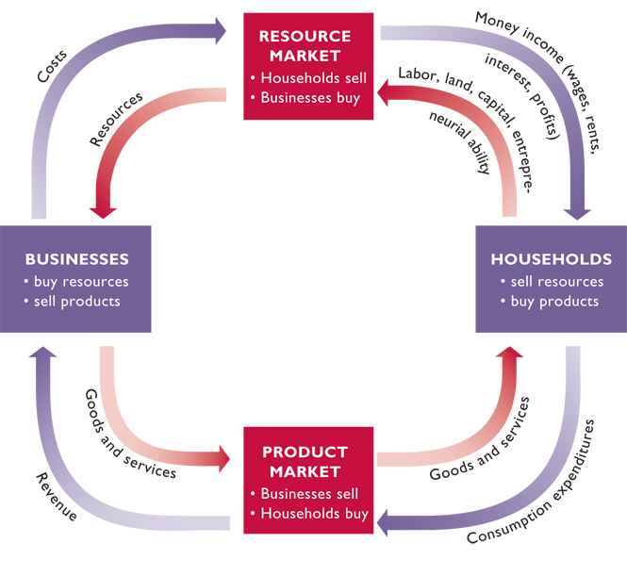
Circular Flow Term | Term From The Story | Circular Flow Term | Term From The Story
1. Households = |  | 2. Consumption Expenditures =
3. Product Market = |  | 4. There are two businesses in the story. If we divided the business box into a top and bottom section, the bottom one business would =
5. Revenue = |  | 6. Goods and Services =
7. Land, Labor, Capital, Entrepreneurial Ability= |  | 8. Resource Market = | Resource Market
9. Resources = |  | 10. Top business =
11. Costs = |  | 12. Money Income =
Getting into the flow

Directions: Put an X under either Product Market or Factor Market to indicate which one is being described:
Example | Resource Market | Product Market
1. A job fair (where people are invited to apply for a job)
2. 10 minute oil change garage
3. A Fast Food restaurant
4. An office with a file cabinet full of job applications and where people are interviewed for jobs.
5. A website where people post job applications
6. Sears shopping website
7. A Temp Agency (Where businesses can hire employees to work temporarily)

Name ___________________________________________________________ Hour ______________
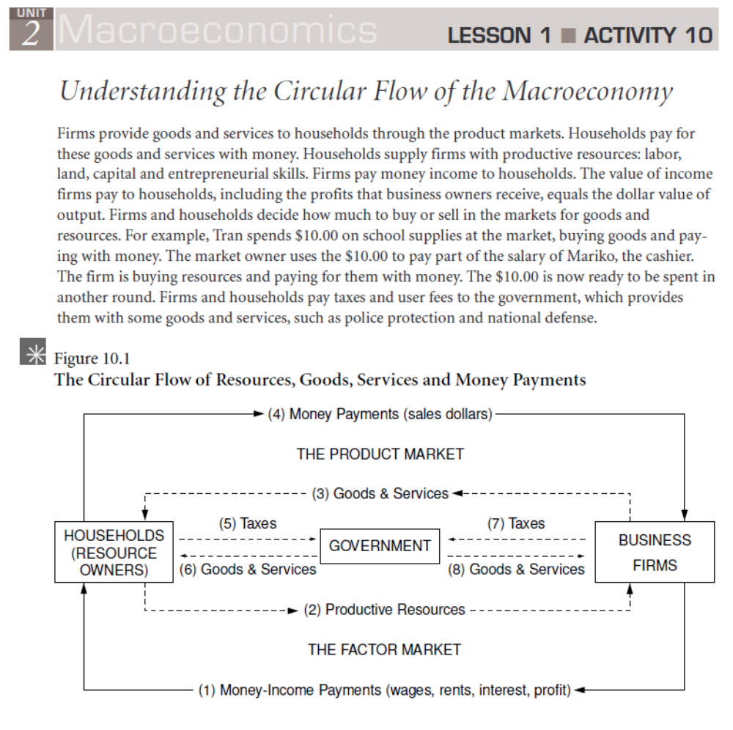

Name ___________________________________________________________ Hour ______________


