AP Exam Registration Information
Registration Period:
Tuesday, January 29th – Friday, February 22nd
Testing Fee: $98.00 per exam
Free/Reduced Testing Fee: $56.00 per exam
Late Testing Registration Fee: $198 per exam
Payment will be collected by Mrs. Downer is the Counseling Center.
Make checks payable to Berkley High School
Please ensure information on receipt is accurate

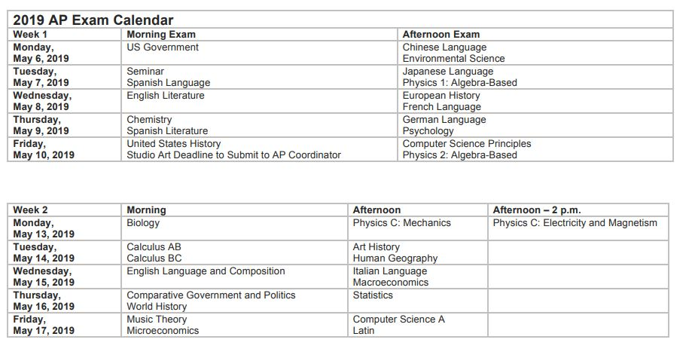
*Students who have two AP exams on the same date and time must choose which exam they will take during the Late Testing Date. No additional fee charged.

