English 12 Summer Reading Assignment
Senior year is undoubtably one of the most challenging years, not only academically but in making life decisions about your future. Mrs. Henderson and Mrs. Lotter will be there, as will your counselors, to help as much as we can. To get you thinking about options, we decided to focus our summer reading on material that can help you start the year running.
Your task is to select any 4 articles and 2 videos. For each, you will complete an evidence interpretation chart below which will not only help you look at the purpose of the writing/video, but will also help you see the impact on you as an individual. These charts (6 in total) will be collected through google classroom upon the start of the fall semester and will lead into our introductory activity, “The Senior Plan.” If you have questions, please contact either Mrs. Henderson at cindy.henderson@berkleyschools.org or Mrs. Lotter at lynn.lotter@berkleyschools.org.
Enjoy and we can’t wait to see you in the fall.
Videos:
https://www.youtube.com/watch?v=k1KoNBu3EfE Dad, why should I go to college?
https://www.youtube.com/watch?v=Fo3e_0ITVjo What should I do with my life?
https://www.youtube.com/watch?v=LIf2zHaTw_I&feature=emb_rel_end 20th Celebration of Americorps
https://www.youtube.com/watch?time_continue=42&v=rhiuBqwdlaA&feature=emb_logo Top 10 Reasons College is Important

Article Titles …See separate SR Articles pdf below to open and read.
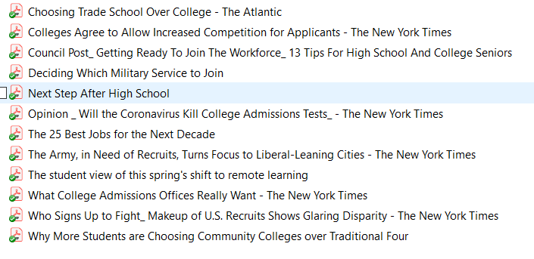

Your Name:
Text Title:
What is the purpose or thesis of this text?

Evidence that supports the purpose of the text | How this impacts me

Was this article/video useful? Explain.

Your Name:
Text Title:
What is the purpose or thesis of this text?

Evidence that supports the purpose of the text | How this impacts me

Was this article/video useful? Explain.

Your Name:
Text Title:
What is the purpose or thesis of this text?

Evidence that supports the purpose of the text | How this impacts me

Was this article/video useful? Explain.

Your Name:
Text Title:
What is the purpose or thesis of this text?

Evidence that supports the purpose of the text | How this impacts me

Was this article/video useful? Explain.

Your Name:
Text Title:
What is the purpose or thesis of this text?

Evidence that supports the purpose of the text | How this impacts me

Was this article/video useful? Explain.

Your Name:
Text Title:
What is the purpose or thesis of this text?

Evidence that supports the purpose of the text | How this impacts me

Was this article/video useful? Explain.

