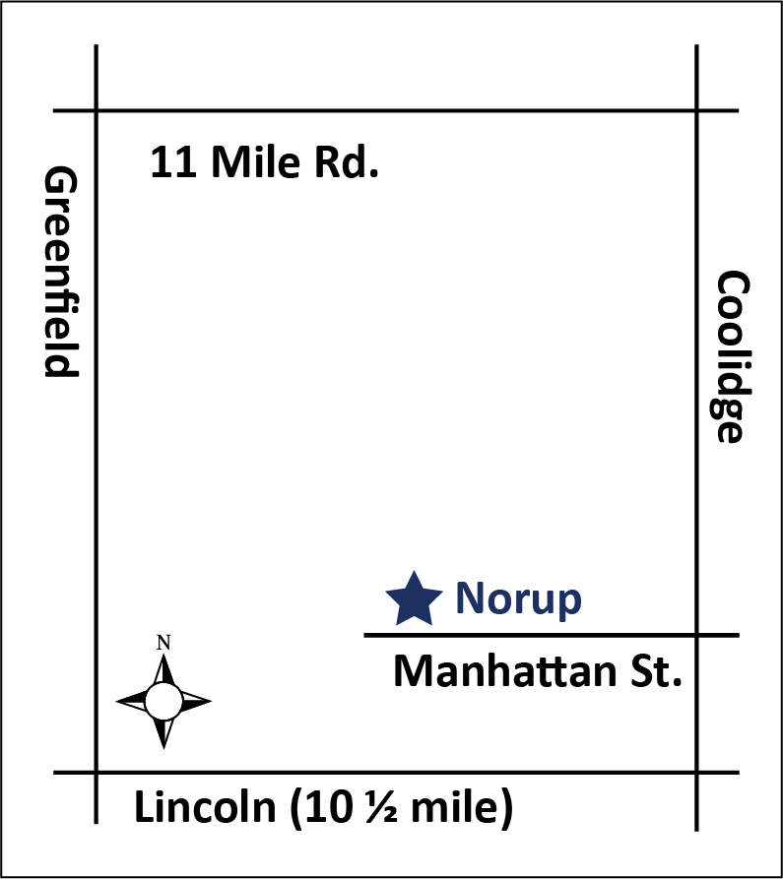
High School
OPPORTUNITIES

June 26 – July 27
All classes held at Norup International School
14450 Manhattan, Oak Park, MI

English/Language | Mathematics | Science | Social Studies | Electives
9th grade Algebra Earth Science US History *Please check with
10th grade Geometry Physical Science World History counselor on offerings
11th grade Algebra II Biology Government
12th grade Pre-Calculus Chemistry Economics
Physics Geography
Health Psychology
Env. Science Sociology

Courses should be selected with consultation from the school counselor. Coursework will be delivered through the APEX online learning system, assisted, facilitated, and overseen by certified teachers. These courses are tailored to each student and are mastery-based — that is, students must demonstrate mastery of the coursework. The length of time students must spend in Summer School will vary and is dependent upon mastery of course objectives. All coursework adheres to and is aligned with the standards and benchmarks of the State of Michigan and the Berkley School District.

Schedule
Students may take up to two classes. Students may choose the time slot during which they take the class(es):
8:00 AM – 10:15 AM and/or 10:20 AM - 12:30 PM. Classes are held Monday - Thursday. We will not meet Monday, July 3 and Tuesday, July 4. Spaces are limited for each time slot, so be sure to sign-up soon.

Lunch is not served on-site, however, breakfast is available every morning for a small fee. Students eligible for free/reduced-fare lunch will also receive breakfast for free or at a reduced rate.
Fees
The fee is $200 per class. Any BSD student who is eligible for free/reduced-fare lunch will receive their first class at a reduced rate of $50/class. Additional classes are at the regular tuition rate. Payment is due at the time of registration.
Students who choose to drop classes will be charged a $30 fee. No refunds will be granted after the second class period.

Required Materials
Students must bring the following items daily:
• Headphones
• Notebook
• Pencils or pens

Behavior/Attendance Policy
Students are responsible for completing coursework during the time-span provided. Academic credit will not be granted if the student does not complete coursework, so attendance is of utmost importance. Students who have more than two absences will be at risk of not receiving academic credit.
Disruptive behavior on school grounds will not be tolerated, and may result in removal from the summer school program. Refunds will not be provided under these circumstances.

Questions? Email: asarris@berkleyschools.org
BSD HIGH SCHOOL SUMMER SCHOOL REGISTRATION FORM
FINAL DAY TO REGISTER IS JUNE 23
Student name: Date of birth: _____________

Address:
STREET CITY ZIP

HOME PHONE PARENT/GUARDIAN WORK/CELL PHONE NUMBER PARENT/GUARDIAN EMAIL ADDRESS (Please print clearly.)
Parent/Guardian Name:

School name: □ Berkley □ Other (name of school and district):

Does your child have an IEP/504 Plan? __ No __ Yes (please explain):
English/Language | Mathematics | Science | Social Studies | Electives
□ 9 Sem. 1 | □ Algebra, Sem. 1 | □ Earth Science, Sem. 1 | □ US History, Sem. 1 | *Please check with
□ 9 Sem. 2 | □ Algebra, Sem. 2 | □ Earth Science, Sem. 2 | □ US History, Sem. 2 | counselor on offerings
□ 10 Sem. 1 | □ Geometry, Sem. 1 | □ Phys. Science, Sem. 1 | □ World History, Sem. 1 | __________________
□ 10 Sem. 2 | □ Geometry, Sem. 2 | □ Phys. Science, Sem. 2 | □ World History, Sem. 2 | __________________
□ 11 Sem. 1 | □ Algebra II, Sem. 1 | □ Biology, Sem. 1 | □ Government
□ 11 Sem. 2 | □ Algebra II, Sem. 2 | □ Biology, Sem. 2 | □ Economics
□ 12 Sem. 1 | □ Pre-Calculus, Sem. 1 | □ Chemistry, Sem. 1 | □ Geography, Sem. 1
□ 12 Sem. 2 | □ Pre-Calculus, Sem. 2 | □ Chemistry, Sem. 2 | □ Geography, Sem. 2
 |  | □ Physics, Sem. 1 | □ Psychology
 |  | □ Physics, Sem. 2 | □ Sociology
 |  | □ Health □ Env. Science

High School Counselor’s signature (required): _____________________________________________________________________
Please check the time slot(s) during which you would like to take class:
(If taking one class, check one time slot; if taking two classes, check both time slots.)

□ 8:00 AM – 10:15 AM □ 10:20 AM – 12:30 PM
Please check applicable fees:
□ One class: $200 Berkley School District Students Only, Reduced Tuition ($50/class) for one class if:
□ Two classes: $400 □ Student is eligible for free or reduced lunch

I understand the behavior/attendance policy of the BSD Summer School Program (on previous page):
Parent/Guardian signature: _______________________________________________________________ Date: ________________
Student signature: ______________________________________________________________________ Date: ________________
___ CHECK ENCLOSED payable to Berkley School District
___ VISA ___ MC CARD NUMBER: _____________________________________________ EXP. DATE: __________

RETURN REGISTRATION FORM WITH PAYMENT IN FULL TO:
BERKLEY SCHOOL DISTRICT
ATTN: SUMMER SCHOOL
14700 W. LINCOLN ST., OAK PARK, MI 48237

FINAL DAY TO REGISTER IS JUNE 23

Questions? Email: asarris@berkleyschools.org

